

LoRaWan public/private gateway

(Topic Analysis)

Word count:

Submitted for : Msc Computer Science (Security and distributed)

Completed by: Ieaun Roberts

Supervisor : Dr John Dixon

Date: 11-01-2021

Abstract

Contents

1. Introduction 3

1.1. Problem 3

1.2. Goal 3

1.3. Ethics, fair use and legal issues 4

2. Background 6

2.1. Introduction to LoRa and LoRaWAN 6

2.2 LoRa / LoRaWAN Packet structure: 8

2.2. The Things Network 11

Hardware systems 12

2.3. Technical background 18

2.4. Modulation techniques 21

2.4 Libraries 26

2.5. Software frameworks, platforms and languages 26

3. Specification and analysis 27

3.1. Specification 27

3.2. Hardware analysis 29

3.3. LoRa use cases and applications 1

4.Development 2

Peer-to-peer end node development 2

Gateway development 4

4. Project management 0

4.1. Timeline 0

4.2. Task list 0

4.3. Overview of tasks 1

4.4. Project risks 2

4.5 Time Plan 0

5. Conclusion, discussion and evaluation 0

6. Appendix 1

Appendix 1.1: Original topic description 1

Appendix 1.2: Ethics form 2

Appendix 1.3: 0

7. References 0

# Introduction

Herein lies the initial research and analysis for the topic titled “LoRaWan public/ private gateway”. This topic revolves around the use of the LoRa and LoRaWAN protocols to facilitate and manage the communication between end nodes, gateways and servers. The primary goal of this project is the development of a LoRaWAN gateway capable of forwarding packets to either a designated private server or “The Things Network”, dependant on the source of the packet.

Within this report we touch on subjects relating to wireless communications while comparing and contrasting the hardware used to enable these technologies and cover aspects relating to project management for the topic.

## Problem

LoRaWAN is only functional with a gateway to forward packets within the vicinity. End nodes broadcast their data and gateways in range receive these packets and typically forward them to “The Things Network” where other applications can obtain the data.

The more gateways available, spread out in different locations, the more usable LoRaWAN becomes.

Private organizations are often uncomfortable with sharing their data with 3rd parties (e.g. the Things Network). This leads to the use of private infrastructure that only routes data to private servers, rendering the infrastructure unusable for outside devices.

What is needed is a gateway capable of forwarding packets to alternating sources:

* 1. Private data sent to requested servers.
  2. All other data sent to the Things Network.

## Goal

Build a multi-channel gateway, create software to meet the outlined functionality, develop a web application to enable users to register end node – server relationships to ensure their data is routed to the correct location and provide an in-depth examination of the LoRa and LoRaWAN protocols.

**End-nodes**

**Gateways**

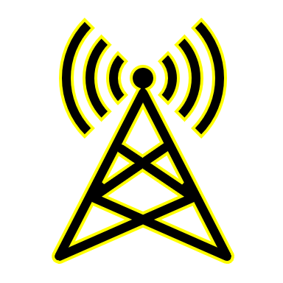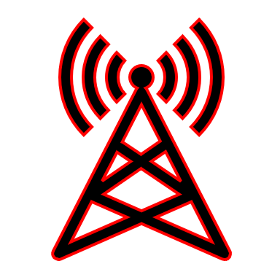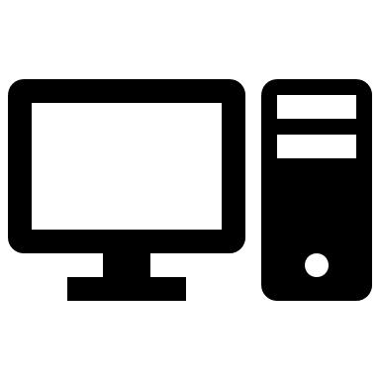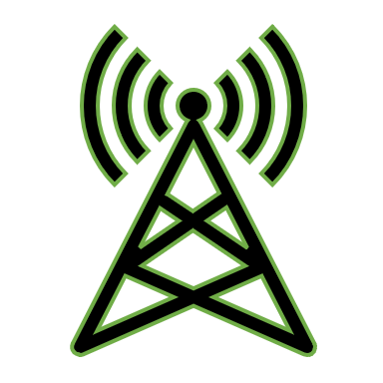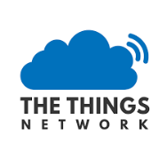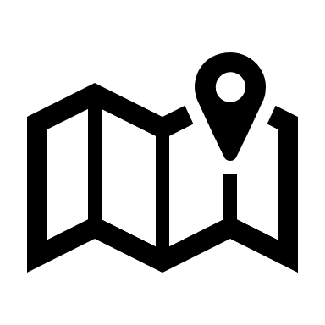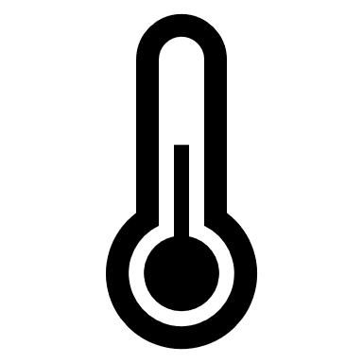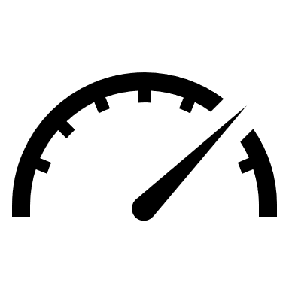

**Figure 1, Proposed public / private LoRaWAN Network topology**

Private

Hybrid

Private

Uplink

Downlink

Public

Application server

Network Server

Application server

Speedometer

Temperature

Location

Humidity

Public

## Ethics, fair use and legal issues

LoRa makes use of unlicensed ISM bands (Industrial, Scientific and Medical) to communicate data. Use of these ISM bands is heavily restricted and anyone intending to create a LoRa based system should familiarize themselves with the relevant documentation regarding which frequency to use, duty cycle limitations, ERP/EIRP and max antenna gains in their country. Systems, installations and infrastructure not upholding local regulations may be punishable by your residing government.

An in-depth breakdown of specific LoRa frequencies per country can be found by visiting <https://www.thethingsnetwork.org/docs/lorawan/frequencies-by-country.html>

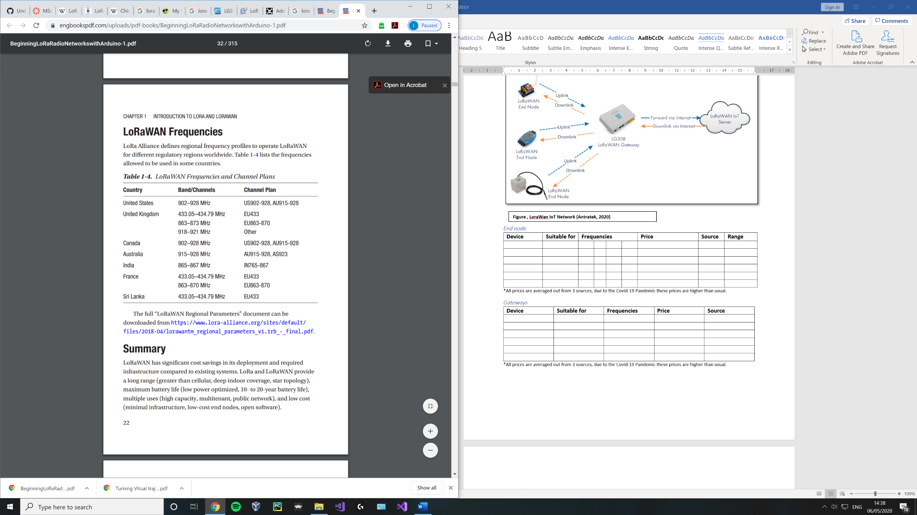

**Figure 2, LoRaWAN IoT Network** (Seneviratne, 2019)

##### Duty Cycle

The duty cycle can be described as a proportion of a period, during which a system’s transmission is allowed to be active and is commonly expressed as a percentage or ratio.

The duty cycle for the EU 863 – 870Mhz ISM band is 1%, other bands, sub bands and locations may have a 0.1% restriction. (lora-alliance, 2015)

A 1% duty cycle indicates a system is not permitted to transmit data on the current band until it has waited for at least 99% of the time it took to send the previous packet.

**Time on air** – the length of the period expressed in time for a sender’s packet to reach a receiver.

**Waiting…**

Signal

Signal

e.g. Time on Air – 620ms

Duty cycle – 1%

99x620 = 61380 = 61.38 seconds

**Waiting…**

Signal

Signal

e.g. Time on Air – 620ms

Duty cycle – 0.1%

999x620 = 619 380 = 619.38 seconds

**Figure 3 adapted from** (Mobilefish, 2018)**, Duty cycle calculation**

Without duty cycles in place limiting use, bands may be rendered unusable akin to a DoS attack and gateway functionality may be affected.

Use of multiple bands / channels to work around this limitation is common practice.

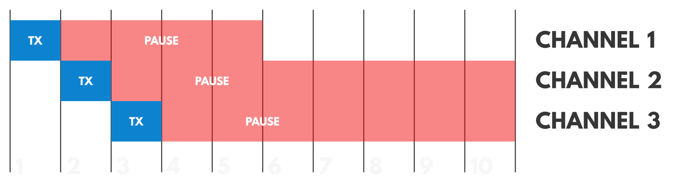

**Figure 4, Multiple sub-band transmission** (thethingsnetwork, n.d.)

##### The Things Network policies

The organizations fair use policy limits each end-nodes transmission in a 24-hour period to a maximum of :

* 30 seconds of uplink airtime.
* 10 downlink messages (including ACKs).

Naturally, any users not making use of the Things Network servers / using a private network need not abide by the limitations and policies set by the things network in their implementations.

(thethingsnetwork, n.d.)

# Background

## Introduction to LoRa and LoRaWAN

#### What is LoRa ?

LoRa (Long Range) is a patented physical layer wireless communication technology developed by Semtech. It is a spread spectrum modulation technique derived from **chirp spread spectrum**. LoRa is a data transmission alternative that is often praised for its low power consumption and long-range abilities and is suited for scenarios where infrequent small data packets need to be sent. It is especially useful in IoT (Internet of things) networks. (semtech, n.d.)

LoRa uses licence free, amateur ISM bands such as 868Mhz in Europe and is able to transmit to various far off distances (greater than current cellular networks) due to its high **link budget**.

|  |  |
| --- | --- |
| **Environment** | **Range (km)** |
| Urban | 2-5 |
| Rural | 5-15 |
| Direct line of sight | >15 |

Figure 5, LoRa range

Record: 436 miles / 702Km, Weather balloon to ground connection (TTN, 2017)

Distance heavily dependent on environment and density of materials within.

LoRa includes the use of several layers of encryption that make use of a:

1. Unique network key.
2. Unique Application key.
3. Device specific key.

(lora-alliance, n.d.)

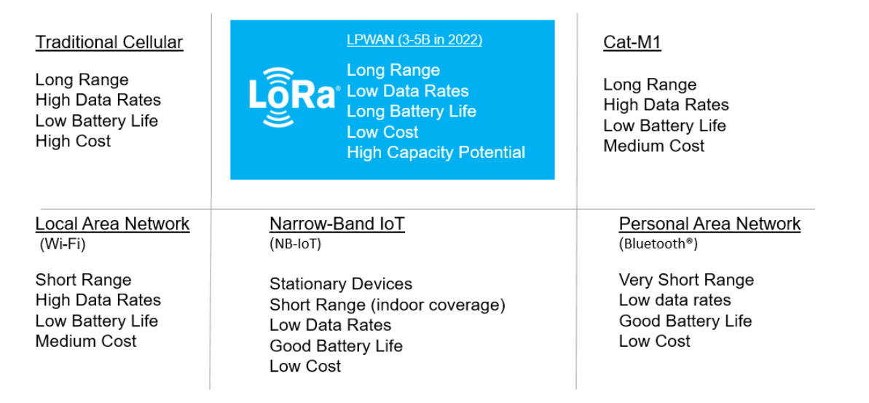

Figure , IOT Technologies (lora-developers, n.d.)

#### What is LoRaWAN?

LoRaWAN is an LPWAN protocol (Low Power Wide Area Network) based on LoRa technology. As with other LPWAN protocols such as Sigfox, it is able to transmit data over great distances at low data rates and minimal power consumption. LoRaWAN defines the upper networking layers and LoRa defines the lower physical layer. “LoRaWAN was designed to wireless connect battery operated things to the internet.” (semtech, n.d.)

LoRaWAN is used to manage and route communications between asynchronous end nodes and gateway devices. Its emphasis is on management of communications and revolves around the architecture of the network, managing communication frequencies and data rates.

LoRaWAN’s network architecture takes the shape of a star-of-stars topology, where an ecosystem of end nodes communicates with a gateway in their vicinity. These in turn forward payloads between the end nodes and centralized servers with the conversion of LoRa radio frequency (RF) packets to Internet protocol (IP) packets and vice versa throughout. (lora-alliance, n.d.)

##### *Sigfox vs LoRaWAN*

Both of these LPWAN protocols seek to target the same markets with similar end goals in the IOT space. Some key differences between these two technologies include:

* Sigfox uses a single hop star topology for its network architecture, where each node communicates with one central coordinator that directs the request to its destination.
* All LoRa communications are encrypted by default, Sigfox communications are “clear” by default.

##### LoRaWAN security

Within the LoRaWAN specification, there are two layers of cryptography defined to satisfy fundamental needs in most use cases of the protocol. These layers of security both make use of 128-bit session keys and an Advanced Encryption Standard (AES-128) algorithm to authenticate, uphold integrity of data sent and received and strengthen the security of the protocol.

The layers are concerned with 2 session keys which are unique for each device on each session. Namely these keys are a **network session key (NwkSKey)** and **application session key (AppSKey)**. These two keys are generated when an end device joins the network and are used for the duration of the session. See the section on end device activation for more on the key exchange procedure.

The network session key is shared with the network and used to validate messages between the end node and network server. This key is used within a Message Integrity Check (MIC) to prevent a packet from being tampered with.

* Prevents packets from being altered on the way, upholds integrity.
* Authentication.

The application session key is kept private and used for end to end encrypting and decrypting of payloads between end nodes and applications.

* Prevents packets from being read.

Additionally, when using the things network, a third key is introduced to authenticate the device and derive the session keys known as the **application key (AppKey)**. Similarly to the application session key, the application key is only known by the device and application.

(lora-alliance, 2015) (GEMALTO, ACTILITY AND SEMTECH, 2017) (The Things network, n.d.)

## 2.2 LoRa / LoRaWAN Packet structure:

In terms of the seven-layer OSI model, LoRa is described as a “purely physical” layer implementation. The LoRaWAN protocol which encompasses LoRa defines a strategy with which a user is able to construct packets covering the physical, datalink and network layers. (Lora-Developers, n.d.)

A typical LoRa packet consists of the following sections (LoRa Alliance, 2017):

* Preamble
* Header (optional)
* Header cyclic redundancy check (optional)
* Physical payload {encrypted using Network security key}
  + MAC Header
  + MAC Payload {encrypted using Application security key}
    - Frame Header
      * **Device Address**
      * Frame control octet
      * Frame counter
      * Frame options (optional)
    - Frame Port (optional)
    - **Frame Payload**
  + Message integrity code
* Payload cyclic redundancy check (optional)

The LoRaWAN specification 1.1 states that when an uplink packet is sent, the end node transceiver inserts all fields other than the payload (header, header cyclic redundancy check and cyclic redundancy check) when in its default mode of operation. (LoRa Alliance, 2017)

The “Physical payload” of the packet contains within it a “MAC Payload” which in turn contains an “Frame Payload” all of which are discussed in the sections below.

##### Radio physical layer

Image of what a preamble looks like ?

When a packet is received it begins with a preamble, this preamble serves the purpose of indicating to the receiver that there is a data stream incoming, allowing it to synchronise with the stream and define the start of the packet. It also indicates the packet modulation scheme used. (Ivy Li, 2020)

The preamble is followed by an optional section which provides additional information on the packet known as the header. A packet which includes an explicit header can reveal the length of the payload in bytes and the coding rate. If a header is provided, then a cyclic redundancy check should be present for this header. Explicit header mode is the default operation mode.  
A packet with an implicit header does not contain a header as described above but instead must be configured on the end node and receiver radio links to indicate a fixed size for its payload length, coding rate and a cyclic redundancy check. This reduces the size of the packet while also minimizing its interpretability by other gateways.

**Cyclic redundancy check** – A hash function technique used to detect errors in digital data by deriving data from a source such as the packet header / the entire packet and creating a new block of data which can be used to define if data is erroneous to uphold its integrity. CRC is a type of checksum. (techopedia, n.d.)

The physical payload contains the data sent in the code rate defined by the header in explicit mode or the configuration in implicit mode. This payload is encrypted using the network session key. (LoRa Alliance, 2017)

A payload cyclic redundancy check is used to detect any errors within the payload and uphold its integrity. In LoRaWAN specification compliant gateways, no payload cyclic redundancy check is added to downlink messages originating from gateways to end nodes in order to keep messages smaller and compliant with ISM duty cycles. (LoRa Alliance, 2017)

A LoRa Uplink packet consists of the following sections:

|  |  |  |  |  |
| --- | --- | --- | --- | --- |
| Preamble | Header (Payload length, CR) | Header CRC | Physical Payload | CRC |

A LoRa downlink packet consists of the following sections:

|  |  |  |  |
| --- | --- | --- | --- |
| Preamble | Header (Payload length) | Header CRC | Physical Payload |

##### Physical layer payload

The physical payload is encrypted using the network session key (NwkSKey) and contains within it 1 of 3 different variations of payload structures dependant on the operation. The operations either handle joining a network, accepting a join request or simply sending a payload containing application data. Each of these 3 commands however do themselves have alternate types of which there are 8 in total which are all shown in figure x. (LoRa Alliance, 2017)

E.g “Confirmed Data Up” and “Unconfirmed data down” both make use of the 3rd variation (Data payload) however “Confirmed Data Up” indicates an uplink which needs to be acknowledged whereas “Unconfirmed data down” indicates a downlink that does not need to be acknowledged.

1) Join-Request / Rejoin-Request:

|  |  |  |
| --- | --- | --- |
| MAC Header | Join-Request or Rejoin-Request | MIC |

Typically, part of an uplink frame used by an end node to request to join a nearby gateways network.

2) Join-Accept:

|  |  |
| --- | --- |
| MAC Header | Join-Accept |

Typically, part of a downlink frame used by a gateway to signal to an end node that it has been accepted to join the network and any received messages will now be forwarded to servers on the network. The MIC is encrypted with the payload and is not a separate field for this frame.

3) Data payload:

|  |  |  |
| --- | --- | --- |
| MAC Header | Mac Payload | MIC |

Within this frame payload is the application layer payload.

The Mac header defines what type of MAC message has been received out of the outlined 8 types in the LoRaWAN specification v1.1 (Join-request, Join accept, Confirmed data up, …).

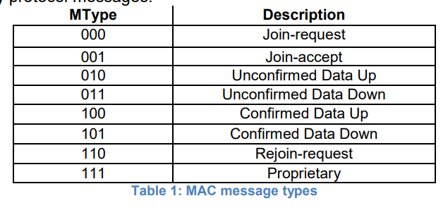

**Figure x, the 8 different MAC message types (LoRa Alliance, 2017)**

**Message integrity code** – a hash function used to verify that a message has not been tampered with and provides a stronger level of authentication than a cyclic redundancy check. (IGI GLobal, n.d.) Its main focuses are to uphold integrity and authenticity. (The Things Network, n.d.)

##### Mac layer payload

The MAC payload is encrypted by the application session key (AppSKey) and contains within it 3 fields:

Mac payload:

|  |  |  |
| --- | --- | --- |
| Frame header | Frame port | Frame payload |

The frame payload field either contains a MAC command or application data, typically if frame port is 0 then the payload contains a Mac command and if the port is 1 – 223 then it contains application specific data. (The Things Network, n.d.)

The frame header contains within it the data required to differentiate devices from one another on the network as well as facilities used to transport MAC commands.

Frame header:

|  |  |  |  |
| --- | --- | --- | --- |
| Device Address | Frame control | Frame counter | Frame Options |

A field of importance in the above structure is “Device Address” which consist of the short device address of the end-device. This address is used to identify the node on the current network and is allocated by the network server. (LoRa Alliance, 2017) (The Things Network, n.d.)

After an end device has joined the network, the device must store the device address and network session key and use them in all future communication. This is discussed in more detail in the device activation section.

## The Things Network

The things network provides a decentralized data network based on LoRaWAN to support in the development of IoT applications. In practice, end nodes transmit data to gateways who in turn forward the data to the Things Network servers where application servers can then receive the end node data and process it accordingly. This allows TTN users a large degree of separation of concern regarding data transmission from a gateway to an application and also allows users to make use of all other public gateways on the network to communicate with far off end nodes. (thethingsnetwork, n.d.)

The Things network has many policies regarding the use of their servers which are discussed in the ethics, fair use and legal issues section of this document.

##### ChirpStack (LoRaServer)

ChirpStack is an alternative LoRaWAN network server that offers similar service to TTN at a local / private level. (chirpstack, n.d.)

## Hardware systems

##### End Nodes

End nodes are typically a battery powered device, making use of some form of sensor (temperature, location, humidity, etc), transmitting its values to a gateway.

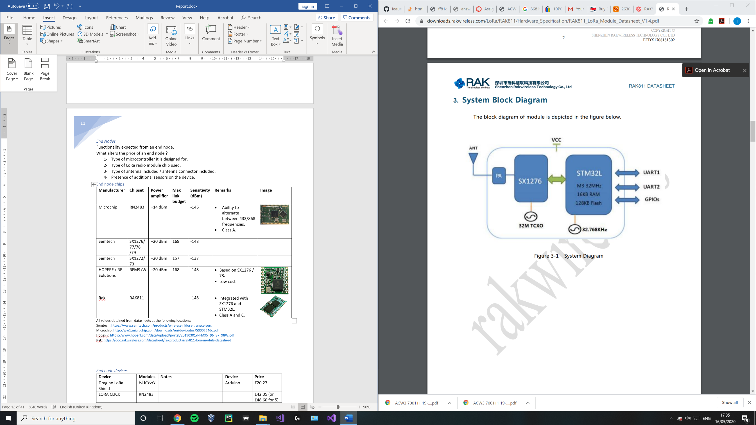Among others, some performance constraints of an end node are determined by:

1. Type of microcontroller / processor.
2. Type of LoRa radio module chip (pictured right).
3. Type of antenna.
4. Presence of additional sensors on the device.

**Figure 6, RAK811 system diagram** (RAK, n.d.)

More fluff

#### Core Components

#### Core functionality

##### Device classes

The LoRaWAN specification defines 3 different classes of end node / end point devices. These classes address the needs of different devices in terms of power consumption and latency. (lora-alliance, 2015)

The following terms are used below in the perspective of an end node:

**Uplink** **(Tx)** – Data transmission from end node to gateway.

**Downlink (Rx)** – Data transmission from gateway to end node, end node must be listening to receive data.

###### Class A (All)

This default class is supported by all devices. For class A devices, each uplink transmission is followed by 2 short windows to receive a downlink response from a gateway. During this period after sending an uplink, the device can enter a low power state while it waits for either of the window times to begin. Once a window period starts, it should listen for a response from a gateway.

Gateways are expected to respond in either the first or second window but not both. If a gateway fails to respond in these windows, the next available receive window for that device will be after the next Tx uplink.

* Lowest power

Downlink window 2 (Rx)

Uplink (Tx)

Downlink window 1 (Rx)

**Time**

**T1**

**T2**

**Figure 7 adapted from** (MobileFish, 2018)**, Class A device**

###### Class B (Beacon)

Furthering class A’s specification, this class provides additional periodical receive windows in the form of “ping slots” within a scheduled allocation of time via beacons. These beacons are determined by the gateway and mark the beginning and end of the period during which the node is listening for packets periodically from the gateway. This leads to a lower deterministic latency when compared to class A devices, this comes at the cost of additional power. (lora-alliance, n.d.)

* Low power
* Low latency

Does this allow end nodes to receive multiple packets ? how are the beacons determined by the gateway ?

**Class A**

Rx

Rx

Rx

Rx

Rx

Tx

**Time**

**Beacon**

**Beacon**

**Ping period**

**Beacon period**

**Figure 8 adapted from** (MobileFish, 2018)**, Class B device**

###### Class C (Continuous)

Furthering class A’s specification, after the two windows have elapsed this class proceeds to continuously listen for responses until this device needs to send another uplink in a half-duplex manner. Gateways communicating with these types of devices may assume that the device is always listening reducing latency.

This class of devices uses far more power and is often mains powered as opposed to battery powered. For battery powered devices, temporary mode switching from class C to class A is possible as defined in the LoRa specification. (lora-alliance, n.d.)

* Lowest latency

**Class A**

Rx (until next uplink)

Rx

Rx

Tx

**Time**

**Figure 9 adapted from** (MobileFish, 2018)**, Class C device**

The above information on classes was adapted from the following sources (lora-alliance, n.d.) (thethingsnetwork, n.d.) (lora-developers, n.d.) (MobileFish, 2018)

Can we get some figures comparing power consumption between class A and B

#### Gateways

LoRaWAN gateways are devices used to receive packets from numerous end nodes in their vicinity and forward them to their destination.

Typically, packets are received simultaneously on multiple channels via LoRa and their payloads are forwarded to standard IP servers over the internet. Multiple gateways can receive a single end nodes broadcast if within the vicinity. (lora-developers, n.d.) (lora-alliance, n.d.) (thethingsnetwork, n.d.)

Among others, some performance constraints of a gateways are determined by:

1. Type of concentrator board used to receive LoRaWAN packets.
2. Type of antenna.
3. Type of LoRa radio module chip used.

Hobbyist implementations of LoRaWan gateways tend to favour an approach where hardware necessary to process LoRa packets is coupled with a single board PC such as a Raspberry PI, Tinkerboard, BeagleBone with an OS such as Linux. This enables the use of open-source software to allow users to modify pre-existing implementations to meet their needs.

To contrast this, industry level gateways are typically (are they also linxu based or are they embedded single devices) …

Every gateway has a:

* Processor to demodulate a signal.
  + In the case of the SX1301, the chip can scan and detect packet preambles in 8 channels and simultaneously demodulate packets on all 8 channels. It is unable to scan and demodulate at the same time. (semtech, n.d.)
* One / two TX/RX radios (SX1255).
* Antenna to amplify signals.

Deduplication of messages

In a scenario where multiple gateways are within reach of a single end node; the network must contain within it means to determine the best gateway to forward any communication (downlink) to and filter duplicate uplinks.

The Things network deduplicates messages received from gateways. If designing a system excluding TTN and making use of multiple gateways, deduplication should not be overlooked.

(thethingsnetwork, n.d.)

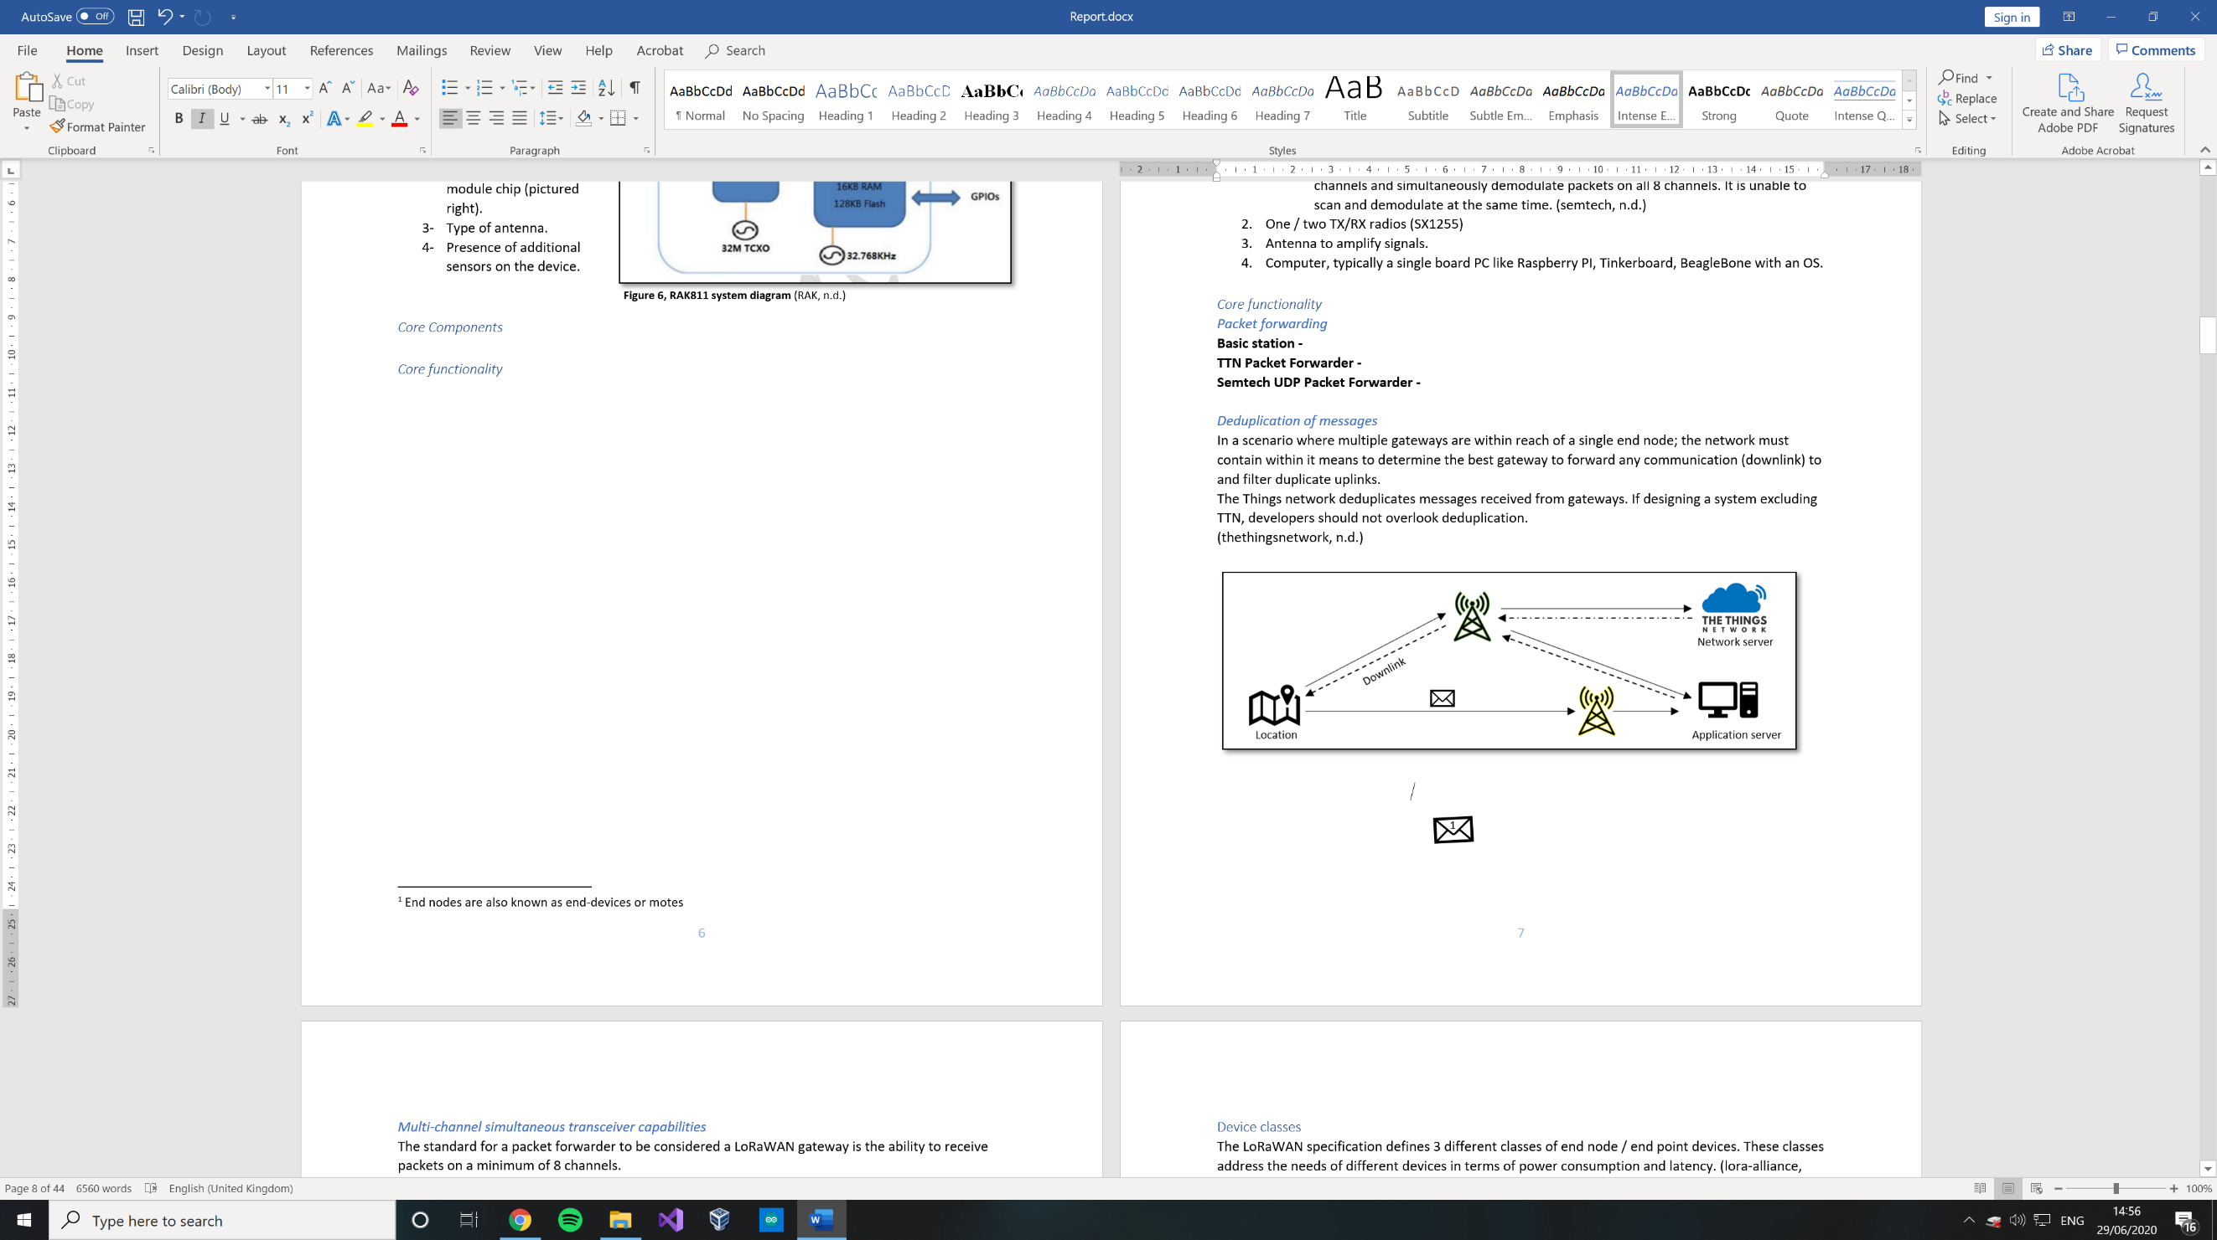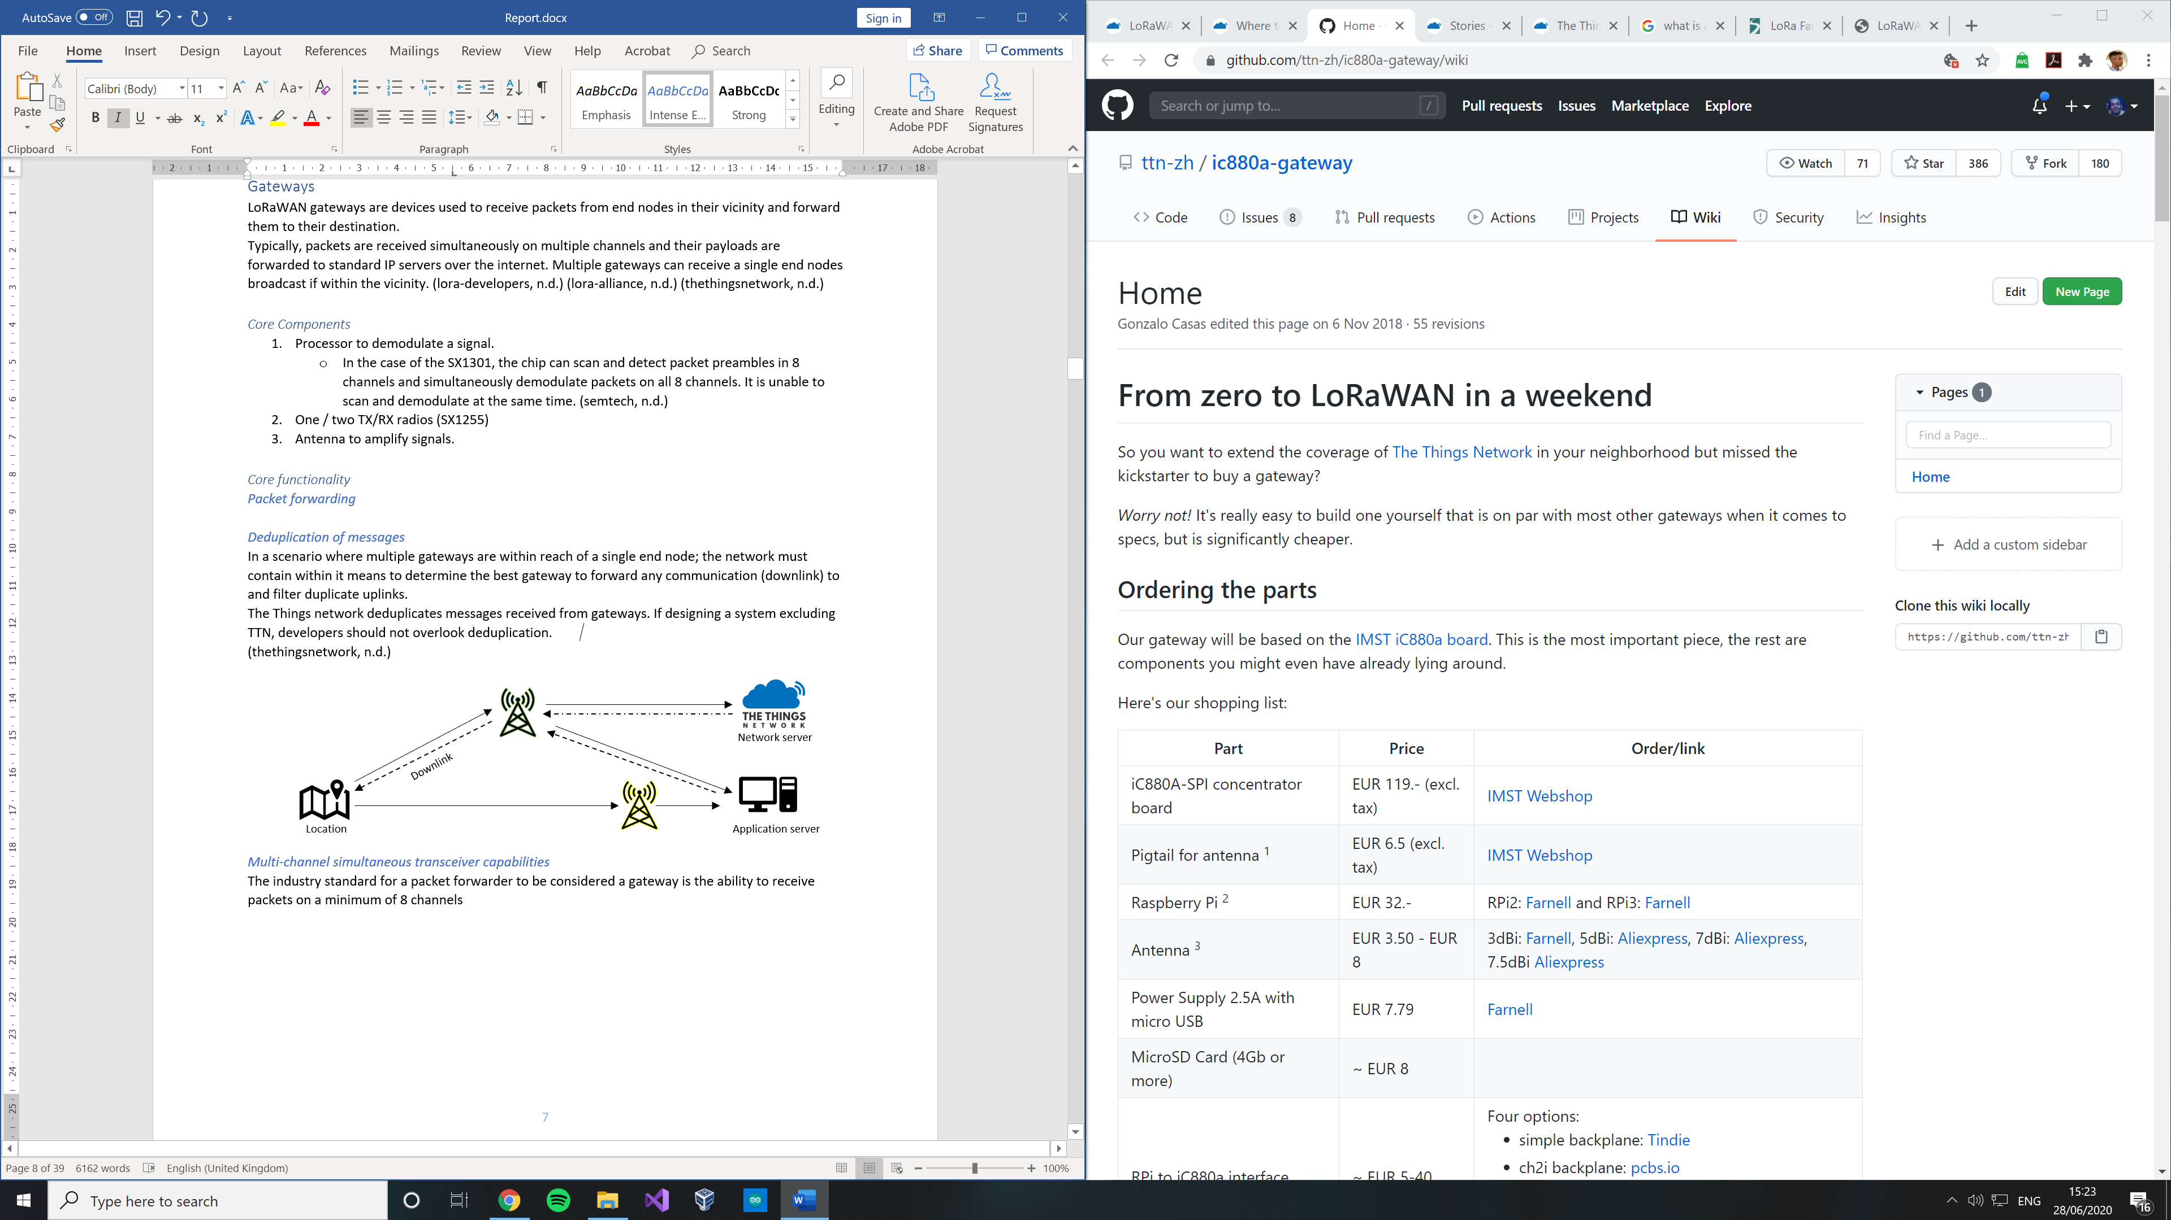

Multi-channel simultaneous transceiver capabilities

The standard for a packet forwarder to be considered a LoRaWAN gateway is the ability to receive packets on a minimum of 8 channels.

**Single Channel Gateways (SCG)–** Single channel gateways are not LoRaWAN compliant and although it was at one point possible to register and make use of TTN with a SCG, they are no longer supported due to their limitations:

1. Often no downlink support.
2. A fragment of the capacity of standard 8 channel gateways, this in turn leads to a false image of the current coverage of a location even with frequency hopping.

Previously a popular proof of concept implementation of a SCG was a project by GitHub user “tftelkamp” titled “single_chan_pkt_fwd”. This project can no longer make use of TTN due to their change in policies.

Downlink support is the deciding factor in regard to using TTN. By implement means of supporting downlink support a user can register a SCG and make full personal use of the servers as demonstrated by the project developed by GitHub user “bokse001” titled “dual_chan_pkt_fwd”.

#### Additional information related to gateways

Base stations / gateways / small cells can all be classified into smaller subsets depending on their coverage radius and power consumption:

* Femto: 10s of meters, 10-100mW
* Pico: 10s of meters, 100-150mW
* Micro: 100s of meters, 5-10W
* Macro: kilometers, > 10W

(Worthman, 2015)

#### End Device Activation

Activation is essentially a registration process whereby an end node requests to join a network so that it can synchronize the keys used for encryption between itself and the network / application servers. There are 2 types of activation methods defined by the LoRaWAN specification however these 2 methods are both themselves different depending on which version of LoRaWAN a developer intends on using, 1.0.x or 1.1 (LoRa Alliance, 2017):

* Over the air activation (OTAA)
* Activation by personalization (ABP)

End nodes need to be activated on a specific network before they can transmit their data or receive any data (The Things Network, n.d.). This is because network session keys as well as a defined device name on the network are exchanged between the network, server and end node (and join server in the case of LoRaWAN 1.1) upon completion of the activation process which will be used to encrypt the physical payload, decrypt any downlinks from the gateway as well as for validation and authenticity.

One of the main architectural differences between version 1.0.x and version 1.1 of LoRaWAN relating to activation is the introduction of the join server. In version 1.0.x the network server would handle the join operations where an end node requests to join to receive the keys in order to encrypt its data. This functionality was broken out into a separate entity in 1.1 with additional security measures added (LoRa Alliance, 2017). More specifically, additional keys have been added to encrypt communications between the end device and network server dependant on the type of operation. (The Things Network, n.d.)

##### Over the air activation (OTAA)

LoRaWAN 1.0.x

What needs to be stored on the end device before activation (LoRa Alliance, 2015):

* Global application Id that uniquely identifies the application (AppEUI, public)
* Global end-device Id that uniquely identifies the end-device (DevEUI, public)
* Application key (AppKey, AES-128 root key)

LoRaWAN 1.1

What needs to be stored on the end device before activation (LoRa Alliance, 2017):

* Global application Id that uniquely identifies the join server (JoinEUI)
* Global end-device Id that uniquely identifies the end-device (DevEUI)
* Application key (AppKey, AES-128 root key, never sent over the network)
* Network key (NwkKey, AES-128 root key, never sent over the network)

In version 1.0.x, 2 MAC messages are exchanged between the network server and end device:

* Join-request – the end device sends the appEUI, DevEUI and Dev nonce (random 2-byte value) to the network server, the network server then communicates with the application server and generates a session key. The join request is processed and a response is sent back if the end device is permitted to join.
* Join-accept (server -> end device) – Once the network server verifies the device can join the network it generates an AppNonce which will be used to derive an Application session key and Network session key on the end device. Additionally, an address for the device on the network is added to the Join-accept among other field such as a specified delay between transmitting and receiving and others.
* After the device receives the Join accept it will be able to encrypt, decrypt and validate communications using the application and network session keys.

The differences between 1.0.x and 1.1 are that AppEUI is replaced with JoinEUI, join requests are forwarded to the Join server which decides on wither to permit the device to join. The join server then responds to the network server with an answer and the network server creates the Join-accept. The join server also then forwards an application session key to the application server on request, typically when the application server receives a packet from that device. This communication between the join server and application sever also introduces more layers of encryption.

##### Activation by personalization (ABP)

LoRaWAN 1.0.x

What needs to be stored on the end device before activation (LoRa Alliance, 2015):

* Network session key (NwkSKey)
* Application session key (AppSKey)
* Device Address (DevAddr)

What needs to be stored on the network server before activation (LoRa Alliance, 2015):

* Network session key (NwkSKey)
* Device Address (DevAddr)

What needs to be stored on the application server before activation (LoRa Alliance, 2015):

* Application session key (AppSKey)

LoRaWAN 1.1

What needs to be stored on the end device before activation (LoRa Alliance, 2017):

* Forwarding network session key (FNwkSIntKey)
* Serving network session key (SNwkSIntKey)
* Network session encryption key (NwkSEncKey)
* Application session key (AppSKey)
* Device Address (DevAddr)

What needs to be stored on the network server before activation (LoRa Alliance, 2017):

* Forwarding network session key (FNwkSIntKey)
* Serving network session key (SNwkSIntKey)
* Network session encryption key (NwkSEncKey)
* Device Address (DevAddr)

What needs to be stored on the application server before activation (LoRa Alliance, 2017):

* Application session key (AppSKey)

In version 1.0.x, the implementation of the ABP is considerably more straight forward when compared to the implementation of OTAA, due to ABP bypassing the Join-request / Join-accept procedure (LoRa Alliance, 2015). In ABP an end device must store within it the session keys and device address, the network server must store within it the exact same Network session key and device address for that end device, finally the application server must store within it the Application session key.

ABP directly ties the end device to the network for its entire lifetime, it is considered the less secure activation method and removes the ability for a device to switch network providers. Each device should have its own unique network and application session key generated in such a way that the process to create the keys cannot be derived from public information, one compromised device should not be able to compromise others (LoRa Alliance, 2015).

In LoRaWAN version 1.1, no join server is used however additional keys are used dependant on the operation the network server is performing.

## Technical background

#### Propagation

Propagation covers the way radio waves travel from a transmitter to a receiver and how signal strength is affected if traveling through a medium.

There are 4 main types of propagation:

1. Line of sight propagation – radio wave transmits directly from sender to receiver without any obstacle in its path. [Figure 10]
2. Propagation through obstacles (penetration) – radio waves lose strength proportional to the conductivity of the material when penetrating through obstacles. [Figure 11]
3. Propagation through reflection – In terms of obstacles within the **Fresnel zone,** radio waves may be reflected off of objects and received later than the original line of sight signal reducing the power of the signal and interfering with other direct signals. Dependant on when a reflected signal is received it can either enhance or cancel out a direct line of sight signal. [Figure 12]
4. Propagation through diffraction – when radio waves have to travel around sharp edges / large objects to reach a receiver. [Figure 13]

Free space loss – the single largest loss in radio communication systems and is due to large distances between senders and receivers. (Mobilefish, 2018)

Receiver

Sender

Receiver

Sender

**Figure 12, propagation through reflection**

**Figure 10, Line of sight propagation**

Receiver

Sender

Sender

Receiver

**Figure 13, propagation through diffraction**

**Figure 11, propagation through obstacles**

Strengthen this with other references

#### Fresnel Zone

The Fresnel zone is an elliptical area centred around the direct line of sight path between a point-to- point sender and a receiver in wireless communications. Any obstacles within this zone impacts signal strength due to either reflection, diffraction or penetration.

**Distance**

**Maximum radius**

**Line of sight**

Sender

Receiver

**Height**

**Height**

**60% clear**

**Figure 14 adapted from** (mobilefish, 2018)**, Fresnel zone**

Altering the distance between the sender and receiver similarly affects the size of the maximum radius of the zone. In the figure above, increasing the distance eventually leads to the ground entering the Fresnel zone causing signals to be reflected to the receiver, interfering with line of sight signals. (Mobilefish, 2018)

General tips to improve Fresnel zone coverage and radio signal performance include:

* Placing receivers at higher locations to avoid interference. At large distances, the earths curvature becomes a factor.
* Ensuring the zone is at least 60% clear of blockage.
* Use of optimized antennas based on regional and environmental factors.
* Ensure antenna polarisation for sender and receiver is the same. (e.g. both vertical)

Strengthen this with other references

#### Link budget

**Modulation** – the process of impressing information onto a radio frequency carrier wave. (britannica, n.d.)

**Demodulation** – recovering information from a modulated radio frequency carrier wave.

The link budget is a metric used to quantify the coverage and performance in terms of signal strength of a wireless communication system. Calculation of the link budget requires a summation of all gains and losses experienced within the sender device after modulation, in transmission and when being received and demodulated.

Additional concepts around link budget include:

Received /Rx power: transmitted power + gains – losses measured in dBm

Received /Rx sensitivity: lowest power level at which the receiver is able to demodulate the signal.

Link margin: difference between received power and sensitivity.

(mobilefish, 2018)

LoRa receivers offer a low sensitivity (typically -148) which means they are able to demodulate signals at lower power levels due to the use of chirp spread spectrum.

Maximum link budgets can be calculated by subtracting the lowest Rx sensitivity from the maximum Rx power. This value can be used to directly compare radio performance.

|  |  |  |
| --- | --- | --- |
| **Chip name** | SX1276 | SX1272 |
| **Rx sensitivity** | -148 dBm | -137 dBm |
| **Rx power** | 20 dBm | 20 dBm |
| **Maximum link budget** | 168 dBm | 157 dBm |

**Figure 15, SX1276 vs SX1272**

Values obtained from datasheets: <https://www.semtech.com/products/wireless-rf/lora-transceivers>

## Modulation techniques

LoRa is able to transmit at a high link budget or across great distances due to its specific modulation techniques. An unaltered radio carrier wave carries no information other than a simple wave pulse at a constant frequency and amplitude. In order for us to impress / encode meaning onto these waves, the signal must be modified according to a standard so that the shape of the wave can be related to some form of data dependant on its frequency, amplitude and time. (Britannica, December 23, 2014) (Seneviratne, 2019)

Different modulation techniques are used dependant on the type of data. In this sub section, basic popular modulation techniques for analogous and digital data discussed and built upon to understand the technique used by LoRa to modulate its data.

* Analog – Amplitude modulation, Frequency modulation, Phase Modulation.
* Digital – Frequency shift keying, Spread spectrum techniques.

#### Amplitude modulation(AM)

For this modulation technique, the strength of the carrier signal wave is varied in proportion to that of the information signal (modulating signal) resulting in changes in amplitude that match the fluctuations in the information signal.

The amplitude can be defined as a measure of change within a given period .This modulation technique does not alter the frequency of the wave. (Seneviratne, 2019) (Britannica, December 23, 2014)

Good for long distances but has low noise resistance / high interference due to natural factors in the environment, such as thunderstorms and other electrical currents that can interfere with the amplitude of the wave.

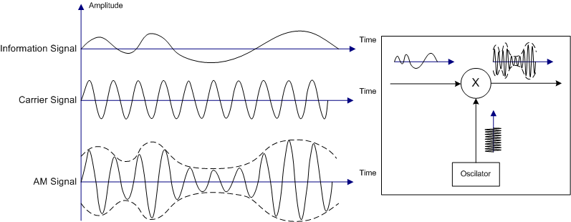

**Figure , Amplitude modulation** (Seneviratne, 2019)

#### Frequency modulation (FM)

For this modulation technique, the frequency of the carrier wave is varied in proportion to that of the information signal resulting in changes in frequency according to the variations in the information signal.

This modulation technique does not alter the amplitude of the wave. (Seneviratne, 2019) (Britannica, December 23, 2014)

Not as good for long distances but has a higher noise resistance when being compared to AM as the frequency of the wave is more resistant to change than its amplitude.

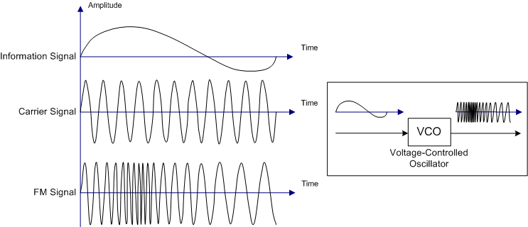

**Figure , Frequency modulation** (Akira, 24 March 2010)

#### Frequency shift keying (FSK)

For this modulation technique, frequency shift keying modulates a carrier signals frequency to impress data. FSK is used with digital signals and the varied analogous information signal as seen above in AM and FM is replaced with a digital binary 0 and 1. This simplified information signal is then used to modulate the frequency of the carrier signal; the modulated signal consists of 2 frequencies which each representing either a 0 or 1 state. (Seneviratne, 2019)

Low power

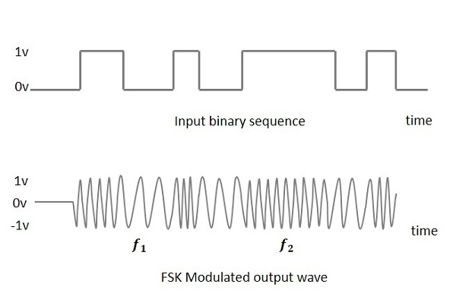

**Figure , Frequency shift keying** (TutorialsPoint, 2016)

##### *Spread spectrum techniques (SS)*

A technique initially developed by the military used to spread a signal over a large frequency band which uses considerably more bandwidth than narrowband signals making it robust to noise encountered in any one channel. Spread spectrum signals are harder to distinguish from noise by any listeners on a given band and not as easily jammed by other signals using the same frequency band making it more reliable. The signal is typically spread via frequency hopping (FH) or direct sequence (DS).

* **Frequency hopping** (FHSS): essentially, the signal jumps (“hops”) in predetermined or random order at specific times between different narrow band channels within a larger encompassing designated bandwidth to avoid interference and eavesdropping. Due to this, the signal is considered more secure.
  + Multiple frequencies, hard to guess currently used frequencies at a given time.
  + Not affected by interference and penetrates through obstacles well.
  + Low cost, low bit rate, commonly used.
* **Direct sequence** (DSSS): when using this technique, each bit of the information signal is multiplied by a secret spreading / chipping code (a key) and transmitted over a large bandwidth. Due to the multiplication, the data stream is larger than it was initially. This technique can look similar to white noise without having the key to decode the data.
  + Single large frequency.
  + Affected by interference and weaker when contrasted to FHSS.
  + High cost, high bit rate.

It is worth noting that both of these techniques add Pseudo random data to their signals.

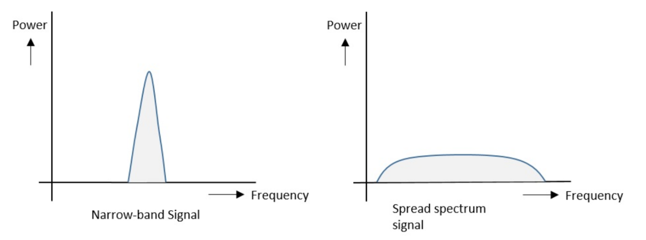

**Figure , Narrowband vs Spread spectrum** (tutorialspoint, n.d.)

Spread spectrum is considered a trade-off of bandwidth efficiency in favour of reliability and security.

(ni, 2020), (Torrieri, 2015) (D-Link, n.d.) (tutorialspoint, n.d.) (ElectronicsNotes, n.d.)

Chirp spread spectrum (CSS)

A spread spectrum technique in which an information signal is modulated into chirp signals. A chirp is a sinusoidal signal (sine wave) within which we observe either an increase (up-chirp) or decrease (down-chirp) in frequency within a signal over time.

A chirp defines a symbol know as a chipping factor which indicates the spread of bits between each chip. The amount of chips per bit is known as the spreading factor (SF). Chirp spread spectrum uses spreading factors (SF) from 7 to 12. A higher spreading factor indicates a lower chirp speed ,lower data rate, larger sensitivity and greater range whereas a lower spreading factor indicates the inverse.

(Seneviratne, 2019) (Telkamp, 2016)

#### Lora spread spectrum

LoRa spread spectrum modulation is derived from **chirp** spread spectrum (CSS).

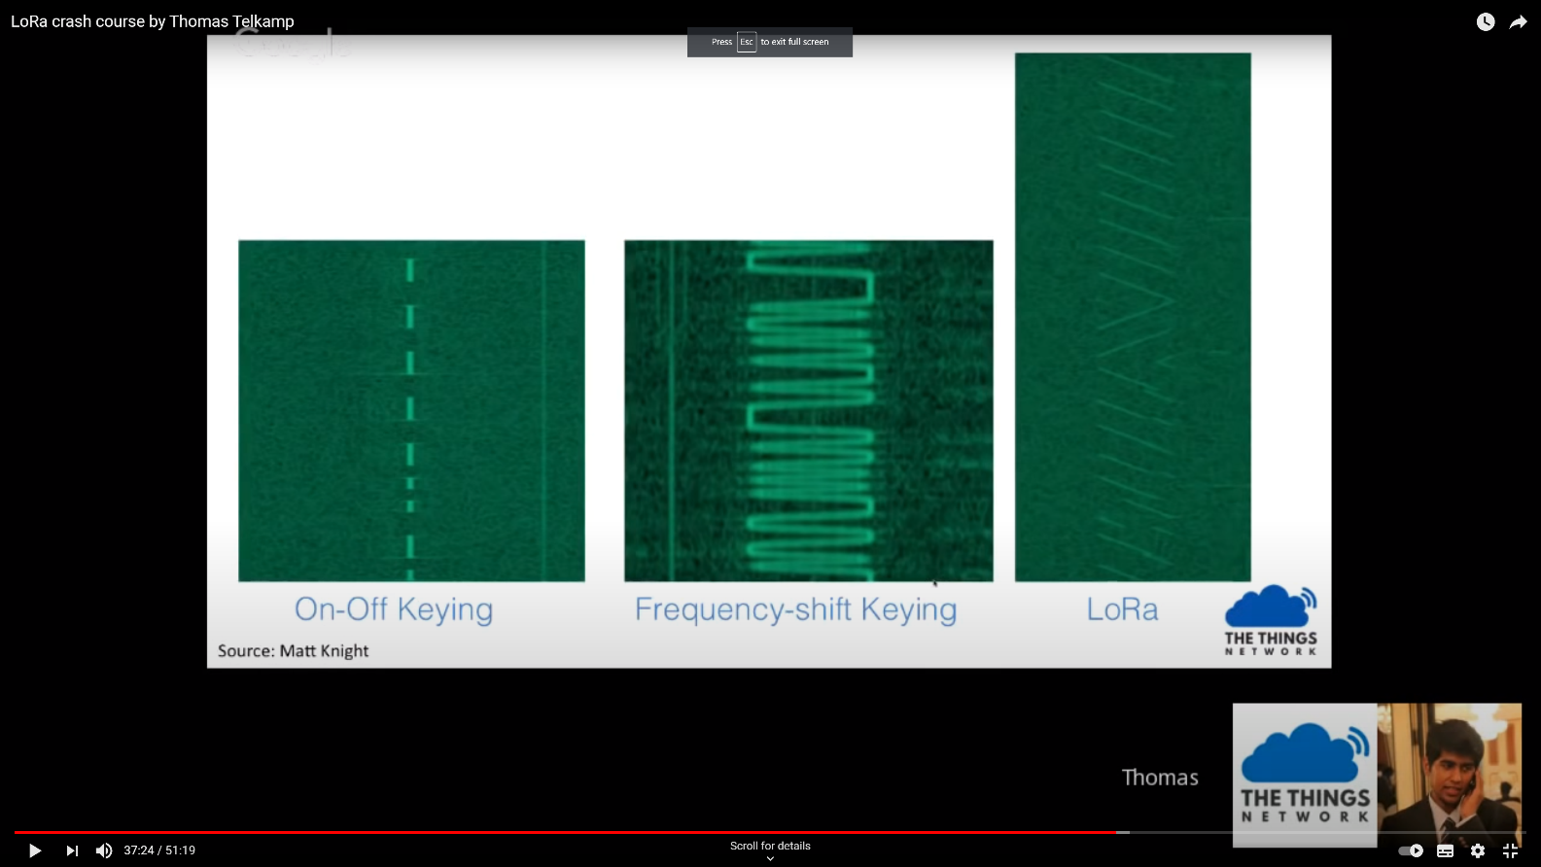

Lora uses orthogonal spreading factors which spread the signal over a spectrum determined by a defined spreading factor. This is extremely useful in making communication more efficient and optimized between individual end nodes and a gateway in terms of power and data rates. (lora-developers, n.d.)

* End device near a gateway does not require high link budget so low spreading factor is optimal.
* End device far from gateway requires high spreading factor is optimal.

High spreading factor results in lower data rate and larger over-the-airtime. Low spreading factor results in higher data rate and less over the airtime. Plagiarism warning*

Low power, high interference resistance, long distances.

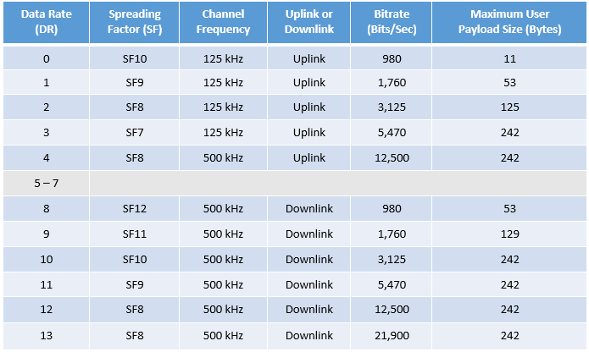

Figure , (lora-developers, n.d.)

## 2.4 Libraries

LMIC

This library was written by developers at IBM in C and then modified so that It can be used in the Arduino environment. This library includes methods that abstract the communication of different LoRa devices such as the SX1272, SX1276 and RFM9x modules making use of device classes A and B. This library is used throughout for the end node development and initial experiments. (Matthijskooijman, 2020)

Note: LMIC is no longer maintained / deprecated and the recommended alternative is a version of LMIC by MCCI.

RadioHead

This library is used to simplify receiving and sending of packets via many different types of radios including LoRa. (McCauley, 2020)

## Software frameworks, platforms and languages

##### Angular (Framework)

Angular is a modern front end application design and development platform used to create sophisticated single-page web applications created by Google. Angular is often hailed as the most powerful and efficient of the JavaScript frameworks / libraries (React, Vue, etc) and includes many tools to increase productivity such as thorough code generation and powerful command line tools via the Angular CLI while constantly emphasising development practices such as unit tests and separation of concerns with its modular nature.

(Angular.io, 2020)

##### Typescript (Language)

Typescript put simply is “JavaScript with type safety”. The language was designed by Microsoft, is open source and many consider the language to fall in between JavaScript and C#. TypeScript extends JavaScript, adding many features that improve the debugging experience. All Typescript code is transformed into JavaScript code via the TypeScript compiler allowing it to run anywhere JS would.

(Microsoft, 2020)

##### C# (Language)

##### Linux

##### Arduino (Language and platform)

Arduino is an open-source embedded device development platform that makes use of a language by the same name which is an extension of C++.

# Specification and analysis

## Specification

The aim of this project is to produce a LoRaWAN gateway capable of handling both private and public end node data to provide a hybrid alternative to closed private LoRaWAN networks which are preferred by industry users due to privacy concerns.

In the hybrid implementation data would be considered private if the end node is registered to the system, otherwise it is assumed public. Private data is forwarded to a specified server, public data is routed to the Things Network.

The work includes extensive research on wireless communication methodologies and LoRaWAN hardware, building a multi-channel gateway, writing software to meet the aforementioned functionality, developing a web application to register end node – server relationships and providing an in-depth examination of the LoRa and LoRaWAN protocols.

#### **Objective 1: Research into wireless communications and LoRaWAN**

The aim of this objective is to obtain a strong foundation in wireless communication methodologies, within which an emphasised amount of care should be given to modulation techniques, radio wave propagation, LPWAN, LoRa and LoRaWAN. Without a solid understanding of wireless communications concepts, justification and contrasting of hardware components will not be possible.

#### **Objective 2: Research into hardware used by LoRaWAN devices**

The aim of this objective is to examine datasheets and online resources with the goal of comparing and contrasting different hardware components that will be used to build the gateway. With some individual components costing over £100, it is important to thoroughly understand the pros and cons of each component.

#### **Objective 3: Create a peer-to-peer LoRa network**

The aim of this objective is to experiment with data transfer using LoRa at a basic level. In this objective, hardware must be obtained, and software must be written (C/ Python/ Arduino) to transfer simple data from one end node and to receive that data on another device.

#### **Objective 4: Further research into LoRaWAN gateway hardware**

The aim of this objective is to finalize the research on LoRaWAN gateway hardware components and to make an informed decision based on prior and current research as well as the peer–to–peer experiment on which components will be ordered.

#### **Objective 5: Creation of a public LoRaWAN gateway**

The aim of this objective is to assemble the obtained hardware, set it up (Linux OS) and write the software necessary to perform typical public gateway functionality (C/ Python/ Arduino) and register the gateway on the things network.

#### **Objective 6: Creation of registration system**

The aim of this objective is the creation of a web application that can be used to register end node – server relationships (Asp.net, SQL server)

#### **Objective 7: Hybrid LoRaWAN gateway**

The aim of this objective is to integrate the registration system with the public gateway to forward any data from registered end points to their required server.

#### **Objective 8: Security concerns**

The aim of this objective is to examine the created system, identify security concerns and rectify them to align with the secure nature of LoRa. This objective will be considered throughout development.

#### **Objective 9: Exploration and implementation of LoRaWAN use cases**

The aim of this objective is to implement a subset of the outline use cases and identify any short comings and possible improvements that could be made to the gateway.

#### **Objective 10: Additional objectives**

The aim of this objective is to use the remaining time to improve the gateway and use the expertise gained throughout the system development and research to identify possible additional objectives that require a more technical and in-depth knowledge of the LoRaWAN protocol.

## Hardware analysis

Semtech has licenced the LoRa IP to a handful of chip manufacturers such as HopeRF, Rak and Microchip. (semtech, n.d.)

Below are initial summarized findings for the following devices, components and modules:

* End node chips (e.g. SX1276)
* End node devices (e.g. Dragino LoRa Shield)
* Gateway chips (e.g. SX1301)
* Gateway devices (e.g. Kerlink WirNet Station)
* Concentrator gateway boards (e.g. iC880A-SPI)
* Single board PC’s (e.g. Raspberry Pi 3 B+)

##### End node chips

Description: these LoRa transceiver chips each contain within them the hardware necessary to make use of the LoRa modulation technique with varying performance with each supporting some or all of the three end node device classes.

These chips are often optimized and intended for use on a single frequency such as 315 MHz, 433 MHz, 470 MHz, **868 MHz** or 915 MHz .

|  |  |  |  |  |  |  |
| --- | --- | --- | --- | --- | --- | --- |
| **Manufacturer** | **Chipset** | **Max**  **Power amplifier** | **Max link budget** | **Sensitivity (dBm)** | **Remarks** | **Image** |
| Microchip | RN2483 | +14 dBm | - | -146 | * Ability to alternate between 433/868 frequencies. |  |
| Semtech | SX1276/ 77/78 /79 | +20 dBm | 168 | -148 | * Extensive datasheet. |  |
| Semtech | SX1272/ 73 | +20 dBm | 157 | -137 | * Extensive datasheet. |  |
| HOPERF / RF Solutions | RFM9xW | +20 dBm | 168 | -148 | * Based on SX1276 / 78. * Low cost. * Extensive datasheet. |  |
| Rak | RAK811 | +20 dBm | - | -148 | * Integrated with SX1276 and STM32L. * Class A and C. |  |

**Figure , End node chips**

All values obtained from datasheets at the following locations:

Semtech: <https://www.semtech.com/products/wireless-rf/lora-transceivers>

Microchip: <http://ww1.microchip.com/downloads/en/devicedoc/50002346c.pdf>

HopeRF: <https://www.hoperf.com/data/upload/portal/20190301/RFM95_96_97_98W.pdf>

Rak: <https://doc.rakwireless.com/datasheet/rakproducts/rak811-lora-module-datasheet>

#### End node devices

Description: Typically, a battery powered device, making use of some form of sensor transmitting its values to a gateway.

|  |  |  |  |  |
| --- | --- | --- | --- | --- |
| **Device** | **Modules** | **Notes** | **Device** | **Price** |
| Dragino LoRa Shield | RFM95W/ SX1276 | Lower current consumption than competing devices. Temp sensor and low battery indicator. | Arduino | £20.27 |
| LORA CLICK | RN2483 | - | - | £42.05 (or £48.60 for 5) |
| I-NUCLEO-LRWAN1 | SX1272 | Accelerometer, humidity, magnetometer, pressure and temperature sensors. | Arduino | £23.64 |
| Dragino Pi shield 113990254 | RFM95W | Lora/GPS | Raspberry Pi | £26.68 |
| Dorji (DRF1276DM) | SX1276 | - | - | £9.10 |
| DM164138 | RN2483 | All in one device with built in sensors / LCD. | - | £56.14 |
| RAK811 LPWAN | RAK811 | Arduino shield / standalone device. | Arduino | £17.17 |
| RAK811 LoRa / Tracker Board | RAK811 | GPS, open source. | - | £40.99 |
| pHat PIS-1128 | RAK811 | - | Raspberry Pi | £29.99 |
| Adafruit LoRa breakout | RFM96W | Breakout board. | - | £15.12 |

**Figure , End node devices**

*Prices are illustrative only and were collected on +-13/05/2020, due to the Covid-19 pandemic and effects on supply chains these prices may appear higher than usual.

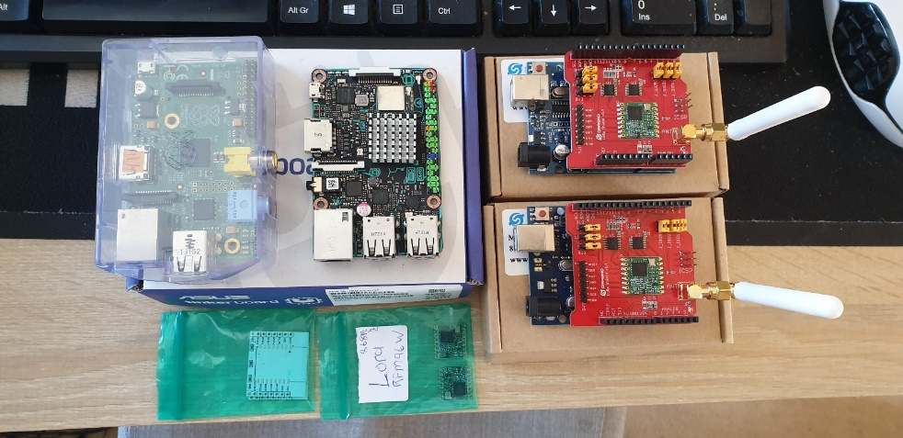

**Figure , 2 obtained Dragino LoRa Shields and 2** **RFM95W modules.**

##### Gateway chips

Description: …

|  |  |  |  |  |  |
| --- | --- | --- | --- | --- | --- |
| **Manufacturer** | **Chipset** | **Sensitivity (dBm)** | **Remarks** | **Max end nodes** | **Channels** |
| Semtech | SX1301 | -142.5 (SX1256)  -139.5 (SX1255) | Emulates 49x LoRa demodulators. | 10000 | 8 |
| Semtech | SX1308 | -139 (SX1255, SX1257) | 70db CW interferer rejection. | 10000 | 8 |
| Semtech | SX1257 | - | RF-to-digital front-end transceiver | - | - |

**Figure , Gateway chips**

All values obtained from datasheets at the following locations:

Semtech: <https://www.semtech.com/lora/lora-products>

##### Gateways devices

Description: …

|  |  |  |  |  |
| --- | --- | --- | --- | --- |
| **Device** | **Chipset** | **Notes** | **Type** | **Price** |
| Mikrotik, LoRa8 | R11e- Lora8 | Listen Before Talk (LBT) and spectral scan features | Outdoor | £156.59 |
| The Things industries, TTIG-868 | SX1308 | USB-c, 900mA, LBT, Lora GW board, Basic station protocol | Indoor | £78.00 |
| TTN-GW-868 | - | No datasheet found for this device | - | £262.10 |
| Dragino LG01N/ OlG01N | SX1276/78  (x2 End node chips) | Single frequency, up to 300 nodes | Outdoor | £57.95 |
| Dragino LG02 | SX1276/78  (x2 End node chips) | Full duplex, 2 channels, optional 3G/4G module. | Outdoor | £74.36 |
| Cisco LoRaWan Gateway | SX1301 (x2) | GPS, rich software features, 16 channels | Outdoor | £2055.21 |
| Kerlink IFemtoCell | SX1301  SX1257 (x 2) | 49 demodulators over 9 channels | Indoor | £266.78 |
| Kerlink WirNet Station | - | 49 demodulators on 9 channels, bidirectional.  Most popular gateway in the UK. | Outdoor | £1010.79 |
| Laird RG186 Sentruis | SX1301  SX1257 | Popular gateway in the UK. | Outdoor | £220.80 |

**Figure , Gateway devices**

*Prices are illustrative only, due to the Covid-19 pandemic and effects on supply chains these prices may appear higher than usual.

All values obtained from datasheets and resources at the following locations:

Laird: <https://connectivity-staging.s3.us-east-2.amazonaws.com/2020-03/CS-PB-RG1xx-GATEWAY_v1_5.pdf>

Dragino: <https://www.dragino.com/products/lora-lorawan-gateway/item/135-lg02.html>

Kerlink:<https://www.thethingsnetwork.org/forum/uploads/default/original/1X/1be8efc08586c0bb5676689df122a3628fe3e0e1.pdf>

Mikrotik: <https://i.mt.lv/cdn/rb_files/1575622904wap%20lora8.pdf>

Cisco: <https://www.cisco.com/c/en/us/products/collateral/se/internet-of-things/datasheet-c78-737307.html>

##### Single board PC’s

Description: …

|  |  |  |  |  |
| --- | --- | --- | --- | --- |
| **Device** | **CPU** | **Ram** | **Remarks** | **Price** |
| Asus Tinker Board | 1.8GHz Quad-core ARM-based Rockchip RK3288 | 2GB | Built in WIFI and Bluetooth. | £62.48 |
| Raspberry Pi 3 B+ | 1.4GHz 64-bit quad-core processor | 1GB LPDDR2 SDRAM | High compatibility and large community. | £27.18 |
| BeagleBone Black | 1GHz AM3358  ARM Cortex-A8 | 512MB DDR3 | - | £49.86 |

**Figure , Single board PC’s**

##### Concentrator gateway boards

Description: These boards provide an all-in-one solution and abstraction of the physical layer / front end. They are all compatible with Raspberry Pi devices through SPI or GPIO and all use the same SX1301 processor or are based on its implementation. Due to this there are very few immediate differences between boards.

|  |  |  |  |  |
| --- | --- | --- | --- | --- |
| **Manufacturer** | **Device** | **Chipset** | **Remarks** | **Price** |
| IMST | iC880A-SPI | SX1301, SX1257 (x 2) | Most popular board. Optional GPS module. | £106.91 |
| Rak | RAK831 | SX1301, SX1257 (x 2) |  | £130.99 |
| Rak | RAK2245 | SX1301, SX1257 (x 2) |  | £129.99 |
| Dragino | PG1301 | Based on SX1301, SX1257 (x 2) | Limited documentation. | £119.91 |
| Mikrotik | R11e- Lora8 / R11e- Lora 9 | Based on SX1301 | Adapter needed for long term use with RPI. | £73.23 |

**Figure , Concentrator gateway boards**

Mikrotik: <https://i.mt.lv/cdn/rb_files/1575622897User%20Manual%20R11e-LoRa8.pdf>

IMST: <https://wireless-solutions.de/downloadfile/ic880a-spi-documents/>

Dragino: <http://www.dragino.com/downloads/downloads/LoRa_Gateway/PG1301/Datasheet_PG1301.pdf>

Rak: <https://cdn.sparkfun.com/assets/d/5/0/7/2/RAK2245_Pi_HAT_Product_Brief_V1.1.pdf>

|  |  |  |  |
| --- | --- | --- | --- |
| **Device** | **PG1301** | **RAK2245** | **iC880A-SPI** |
| **GPS Module** | Included | Included | Optional |
| **Channels** | 10* | 8 | 8 |
| **Radio** | SX1257 (documentation does not specify amount) | 2 x SX125x Tx/Rx | 2 x SX1257 Tx/Rx |
| **Sensitivity** | -142.5 dBm | -139 dBm @SF12 | -137 dBm |
| **Interface** | GPIO (PI Hat) | GPIO (PI Hat) | SPI |
| **Antenna connectors** | SMA | UFL (IPEX) | UFL (IPEX) |
| **Remarks** | Limited documentation. | Small form factor when compared to IC880A. Easy to install. | Many online resources and source code available. Requires an adapter for long-term use with RPI. |
| **Image** |  |  |  |

*The PG1301 datasheet and manual does not define nor mention that the product is able to make use of 10 channels. The Dragino webpage, however, lists it as a 10-channel device.

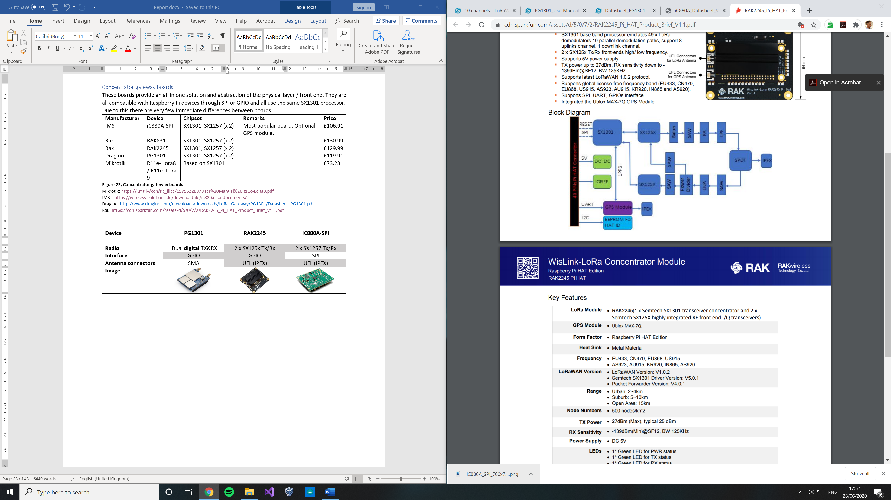

**Figure x, RAK2245 block diagram taken from datasheet.**

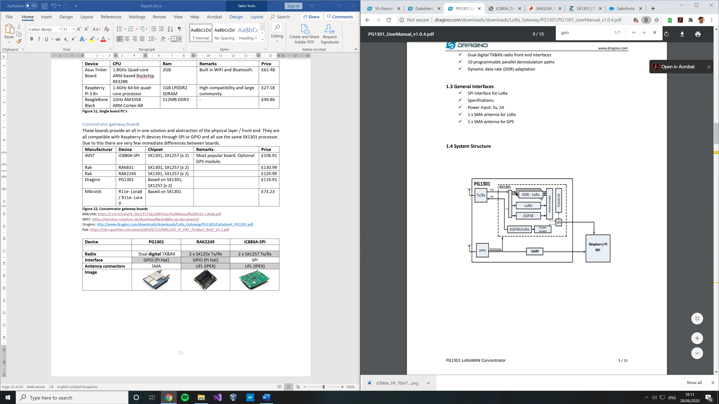

**Figure x, PG1301 system structure diagram taken from datasheet.**

##### Antennas

Description: …

|  |  |  |  |
| --- | --- | --- | --- |
|  |  | **Remarks** | **Price** |
|  |  |  |  |
|  |  |  |  |

##### Overview of gateways in Hull, UK

##### What gateways are others using ?

|  |  |  |
| --- | --- | --- |
| **No** | **Brand / Model** | **Altitude (m)** |
| 1 | - | 150 |
| 2 | Raspberry Pi based, IMST | - |
| 3 | The Things Gateway | 34 |
| 4 | Raspberry Pi based, RAK831 | 1 |
| 5 | Raspberry Pi based, IMST | - |
| 6 | Raspberry Pi based 3 - 868.5Mhz | 8 |
| 7 | The Things Indoor Gateway | 3 |
| 8 | Mikrotik, LoRa8 | 15 |
| 9 | Mikrotik, LoRa8 | 5 |
|  | | |
|  | LoRa8 / raspberry pi IMST | 36 |

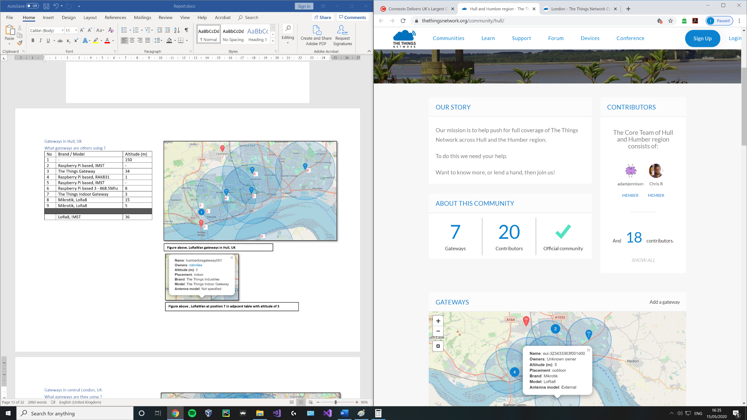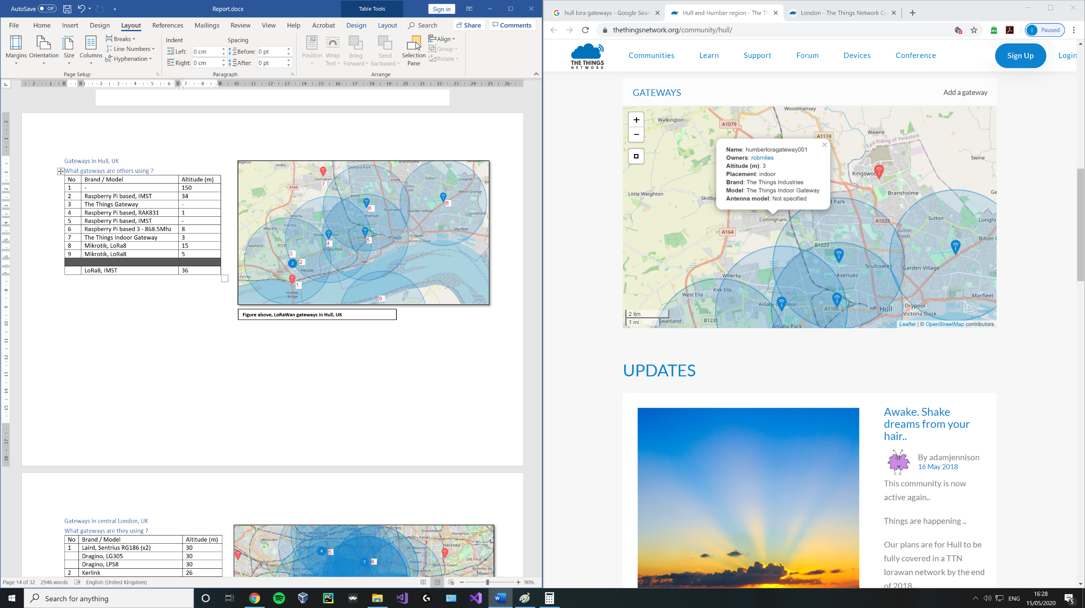

**Figure , LoRaWan gateway at position 7 in adjacent table with altitude of 3** (thethingsnetwork, n.d.)

**Figure , LoRaWan gateways in Hull, UK.** (thethingsnetwork, n.d.)

##### Summary of Overview

|  |  |  |  |  |
| --- | --- | --- | --- | --- |
| **Location** | **Number of gateways** | **Number of contributors** | **Most common device** | **Average altitude** |
| **Hull** | 7 | 20 | LoRa8 / raspberry pi IMST | 36 |
| **London** | 59 | 61 | Kerlink | 43 |
| **Manchester** | 11 | 46 | Kerlink, Station | 46 |
| **Liverpool** | 32 | 22 | IOTLTD v. 10 | 58 |
| **Birmingham** | 2 | 38 | The Things Indoor Gateway | 20 |
| **Leeds and Bradford** | 20 | 40 | Kerlink, Station / MultiTech, Conduit | 92 |

**Figure , Summary of Overview**

* See [Appendix 1.2] for overview of gateways used in London, Manchester, Birmingham, Liverpool and Leeds / Bradford.

|  |  |  |
| --- | --- | --- |
| **Rank** | **Device** | **Count** |
| 1 | The Things Indoor Gateway | 11 |
| 2 | Kerlink Station | 7 |
|  | Laird, Sentruis RG186 | 7 |
| 4 | The Things Gateway | 4 |
|  | Raspberry Pi based, IMST | 4 |

**Figure , Most popular devices from subset of locations in the UK**

*Only includes results where specific device name was provided.

*Number of gateways available and their altitude is constantly changing every day.

From the above overview of several cities in England, we can deduce that cities that are considered tech hubs are dominated by Kerlink gateways in the UK.

Kerlink was one of the initial players in the LoRaWan device market and its “Wirnet Station” holds the accolade of being the first LoRaWan gateway commercially available on the worldwide market launching in 2014. (kerlink, n.d.)

This predates both:

* The initial LoRaWan specification release by the LoRa Alliance in Jan 2015. (N. Sornin (Semtech), 2015)
* The Things Network launch in 2015. (wienkegiezeman, 2015)

Kerlink WirNet Stations are carrier grade private gateways intended for industry customers. Prices for a single base station range from £1010.79 - £1470.75 and include robust software and access to Kerlink’s “ITalks” LoRaWan server.

Further investigation is required into the functionality, hardware and technical operations in order to understand why WirNet and its later versions are still the preferred industrial gateway device for many experts.

## LoRa use cases and applications

#### Smart utilities

Automated meter reading.

Home and building automation.

Street lighting.

Smart parking.

Abnormal energy use detection.

Smart bus schedule signs.

#### Health and hygiene

Disaster precaution.

Waste management.

Food temperature control.

IoT connected hearing aids.

Alzheimer / Dementia patient tracking.

Smart wearables.

#### Safety

Off grid mobile phone messaging (Skrypt, 2019)

Wireless alarm and security systems.

Connected plugs for energy monitoring.

Water leak detection.

#### Efficiency

Industrial monitoring and control.

Location tracking.

Smart mining solutions.

Remote sensors in harsh environments.

#### Agriculture

Long range irrigation systems.

Environment monitoring.

Smart cattle ranching.

#### Other

IP over LoRaWan (Cola, 2018)

Majority of the use cases obtained on Semtech’s LoRa applications page. (semtech, n.d.)

For 1 of each of these categories, explain how the technology is being used e.g. temp sensor monitoring heating in waste management, data is transferred via lora.

# 4.Development

Hardware procured for project:

|  |  |  |  |
| --- | --- | --- | --- |
| **Device** | **Type** | **Quantity** | **Total** |
| Arduino mega | Microcontroller | 1 @ (£8.21) | £8.21 |
| RFM96W | End node chip | 2 @ (£7.15) | £14.30 |
| Dragino Lora Shield (v1.4) | End node device | 4 @ (£20.27) | £81.08 |
| Dragino Pi Lora/GPS hat | Gateway device* | 1 @ (£30) | £30 |
| - | Antenna | - | - |
| - | Gateway device | - | - |
| - | Concentrator board | - | - |
| Asus Tinker board | Single board PC | 1 @ (£15) | £15 |
|  | | | £148.69 |

* Dragino Pi Lora/GPS hat is a single channel device and not considered a gateway in the traditional sense. This device is based on the …
* Dragino Lora shield uses a RFM95W chip.
* All devices are communicating on the 868 MHz frequency band.

## Peer-to-peer end node development

Initial practice experiments were conducted using the Dragino LoRa shield devices for Arduino.

The goal of these experiments was to understand what ideal traits are required from a LoRa transceiver and the justification for a gateway by observing the limitations of typical end node devices communicating with one another.

##### Experiment 1 – Receiver & transmitter

**Setup**

Required libraries: LMIC

Required hardware: 2x Dragino Lora Shield, 2x compatible Arduino devices

1. Attach shields to Arduinos.
2. Download and install the LMIC library and ensure to adjust its source code to reflect your required frequency at Arduino > libraries > LMIC > src > LMIC > config.h > uncomment required frequency (“define CFG_eu868 1”) and comment out unused frequency. Similarly, uncomment the used radio chipset (“define CFG_sx1276_radio 1”) and comment out the unused radio.
3. Dragino recommends the use of example sketch “ttn-abp” for 868 MHz devices.
4. Modify pin mapping as following within the sketch:
   1. 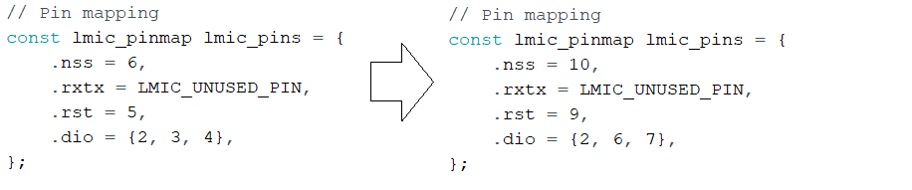

##### Experiment 2 – Both transceivers

**Setup**

Required libraries: RadioHead

Required hardware: 2x Dragino Lora Shield, 2x compatible Arduino devices

1. Attach shields to Arduinos.
2. Download and install the RadioHead library and ensure to adjust its source code to reflect your required frequency at Arduino > Libraries > RadioHead > RH_95.cpp > change line “setFrequency(434.0)” to use your required frequency.
3. Use the RadioHead example sketches rf95_client and rf95_server.
4. Change “int led = 9” to “int led = 8” in rf95_server.

**Remarks**

With very little modification of the example code provided by RadioHead, it is possible to setup communication between 2 end nodes, where each sends a message and essentially acknowledges that it has been received.

(Dragino, 2020)

##### *Identified limitations*

## Gateway development

#### Planning

Public gateways that forward packets to the things network would theoretically need to be configurable in terms of server preset selection / custom server selection in order to set them up to forward these packets to the correct server for a user’s region and this would be an essential feature of any private gateway.

By making use of the earlier research into the commonly used gateways in the UK, it is true that this is possible with the 3 most popular LoRaWAN gateway model series:

* The Laird Sentruis RG1xx (Laird, 2017)
* The Things indoor gateway (The Things Network, n.d.)
* The Kerlink wirnet station (The Things Network, n.d.)

Any solution developed would need to be independent of the type of gateway hardware as there are a subset of gateways that do not make use of open-source software or allow custom firmware on their gateways. Compatibility is a must.

With this in mind and after the early stage experiments it was possible to begin planning on an architecture for a software-based solution which would handle packets received by the gateway hardware and sit as an intermediary between the private server and gateway before sending them to either the private server or the things network.

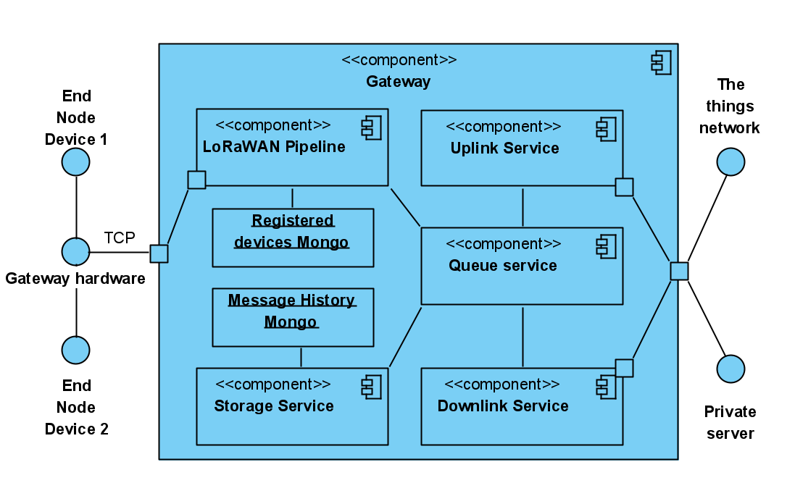

**Figure x, Gateway intermediary component diagram**  
  
At a glance: Microservices (.Net Core), Containers (docker), MongoDb, RabbitMq

The initially proposed architecture would heavily employ the use of containerized microservices and RabbitMQ to facilitate the communication of these messages between containers. The main design goals were compatibility through using modern techniques and technologies.

Why microservices?  
Microservices are described as highly maintainable, strongly emphasizing loosely coupled design and should normally be independently deployable (Microservices.io, n.d.). In the context of this project where there seemed to be many unknowns and uncertainties in the early stages, a microservice approach could be used efficiently to single out key functionality to work on independently from functionality that still needed to be refined and reviewed. A monolithic application could have had any number of setbacks regarding usability across linux, windows or being deployed into the cloud. Developing with containerized microservice running .Net core applications upholds the compatibility across the machines used to develop this project and run the software once completed.

Why docker?

Microservices in tandem with docker containers allow for a level of scalability in terms of distributed computational power that is very desirable in the modern-day software eco system. Containers also drastically abstract deployment of software to a customer’s location be it in the cloud or on premises.

Why mongo ?

Why rabbitMq ?

How are packets/ end nodes differentiated from the public ones?

How will users be authenticated to register new end nodes?

Application server functionality:

* Deduplication of packets received from a single source at the same time.
* Means of pathfinding to determine the best gateway to forward any communication to for a specific end node.

Gateway functionality

# Project management

## Timeline

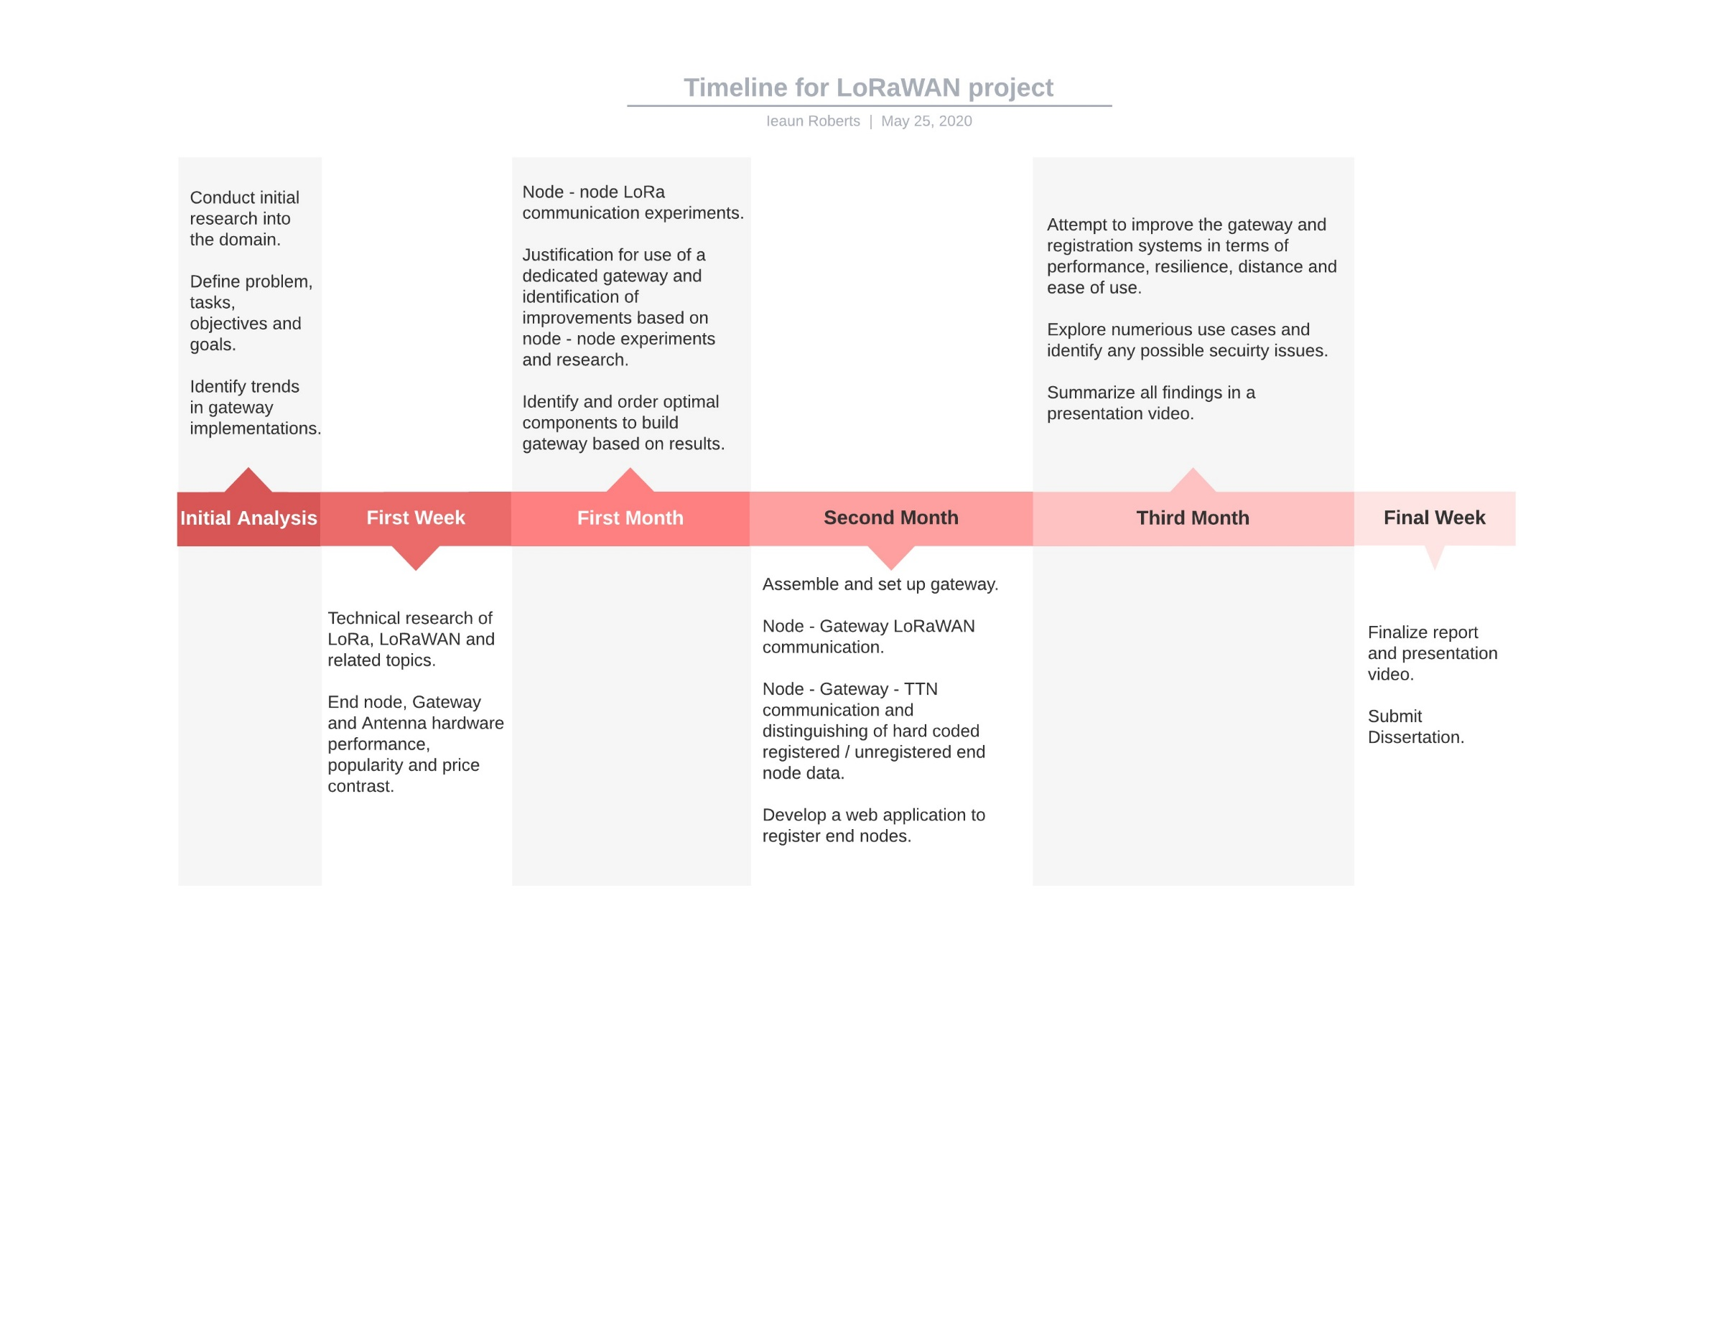

**Figure , Timeline for project made using LucidChart**

## Task list

|  |  |  |  |
| --- | --- | --- | --- |
| **#** | **Task name** | **Description** | **Duration (Days)** |
|  | **Research** | |  |
| 1.1 | Wireless communications | Propagation, Fresnel zone, link budget and margin, antennas and their configurations, packet forwarding techniques. | 3 |
| 1.2 | LoRa and LoRaWAN theory | Chirp speed spectrum, architectures, | 5 |
| 1.3 | (Optional) Encryption techniques | Investigate the practicality of encrypting easily obtained end node data and select a suitable technique to use. | 3 |
|  | **End node** | |  |
| 2.1 | Hardware | Research, compare and procure multiple optimal end node devices/end node hardware. | 3 |
| 2.2 | System design | Uml diagrams, prototype, requirement scoping | 1 |
| 2.3 | Software | Write / obtain libraries and code to make use of the purchased LoRa hardware on the devices. (Python or C/C++) | 2 |
| 2.4 | Node – Node communication  (peer- to- peer) | Create a single channel network of end nodes capable of communicating with one another and note the drawbacks. Justify the need for a dedicated gateway. | 2 |
|  | **Gateway** | |  |
| 3.1 | Hardware | Research, compare and procure a single board PC (e.g. Raspberry PI), a suitable antenna and LoRaWAN based hardware (concentrator, chips) | 7 |
| 3.2 | System design | Uml diagrams, prototype, requirement scoping, UI design | 1 |
| 3.3 | Software | Select / Setup the OS, obtain libraries / drivers and write code to make use of the purchased LoRaWAN hardware. (Python or C/C++) | 5 – 8 |
| 3.4 | Node – Gateway communication | Create a private LoRaWAN network within which the gateway is able to receive communication from end nodes. | 3 |
| 3.5 | Node – Gateway – TTN communication | Connect the previously created Node – Gateway network to the things network. | 1 |
| 3.6 | Private / Public differentiation | Adapt system to send all data from a specific registered end node to an alternate network and all other data to TTN. | 2 |
| 3.7 | (Optional) Investigate and implement remote control software | Investigate and select a method to remotely control the gateway at an OS level and adjust its settings without moving or disrupting its services. | 2 |
| 3.8 | (Optional) Packet encryption | Encrypt packets before sending them to a private server. | 1-2 |
| 3.9 | (Optional) host end node data. | Extend the gateway to include an expandable storage layer used to save private end node data. | 1-3 |

|  |  |  |  |
| --- | --- | --- | --- |
|  | **Registration web application** | |  |
| 4.1 | System design | Uml diagrams, prototype, requirement scoping, UI design | 1 |
| 4.2 | System creation | Write the code for the application and integrate it with the gateway system to update registered end points and their server location. | 2 |
| 4.3 | Unit tests | Tests the system to ensure it behaves appropriately. | 1 |
|  | **Security concerns** | |  |
| 5.1 | Examine system | Review the system and note any potential security flaws in found. Produce a threat model. | 2 |
| 5.2 | Modify system | Make modifications to uphold security based upon the attack surface determined in the previous threat model. | 5-7 |
|  | **Gateway improvements** | |  |
| 6.1 | Critique the system | Identify the gateways weak points and attempt to improve them. | 7 |
| 6.2 | (Optional) Design a gateway case | Design a 3D printable weather resistant case for the gateway. | 2 - 4 |
|  | **Other** | |  |
| 7.1 | Report | Report describing the systems created, planning, development process, experiment results and background. | Ongoing |
| 7.2 | Presentation Video | Video demonstrating all created systems highlighting their functionality. | 5 |
|  | **Supplementary work** | |  |
| 8.1 | Use cases experiments | Implementation, demonstration and critique of numerous use cases. | 7 |
| 8.2 | Security aspects | Investigate any possible dangers and weaknesses that using LoRa / LoRaWAN introduces. | 5 |

**Figure 28, Task list**

* 1. Overview of tasks

|  |  |  |  |
| --- | --- | --- | --- |
| **Task type** | **Number of tasks** | **Total duration (days)** | **Total duration (weeks)** |
| Research | 3 | 11 | 1-week , 4 days |
| End node | 4 | 8 | 1-week, 1 day |
| Gateway | 9 | 29 | 4-weeks, 1 day |
| Registration web application | 3 | 4 | - |
| Security concerns | 2 | 9 | 1 week, 2 days |
| Gateway improvements | 2 | 11 | 1-week, 4 days |
| Other | 2 | 5 | - |
| Supplementary work | 1 | 12 | 1- week, 5 days |
|  | | | |
| **Total:** | 24 | 80 | 12 weeks, 5 days (2.7 months) |

**Figure , Overview of tasks**

## Project risks

|  |  |  |  |  |
| --- | --- | --- | --- | --- |
| **Title** | **Likeli-hood** | **Seve-rity** | **Impact to project** | **How to recover** |
| Hardware breaking / malfunctioning | M | M | Delay in practical deliverables. | Attempt to fix hardware, if beyond the scope of repair order a replacement device. |
| Ordering incompatible hardware | L | H | Delay in practical deliverables. | Attempt to get a refund and order the correct device. |
| Loss of data | L | H | Loss of progress. | Make use of source control such as GIT. |
| Focusing too much on the engineering side of LoRa and wireless communications | H | H | Far more time will be spent researching and attempting to understand concepts. | Focus on system development and the outlined objectives. |
| Inability to work due to illness | M | M | Objectives may be delivered later than initially expected. | Allow some time for unexpected issues occurring in the time plan. |
| Non-compliance with radio use laws | H | H | Possible issuing of cease and desist/ legal consequences.  Project termination. | Ensure all initial experiments are compliant with the outlined “1.3 Ethics, fair use and legal issues” section. |

**Figure , Project risks**

4.5 Time Plan 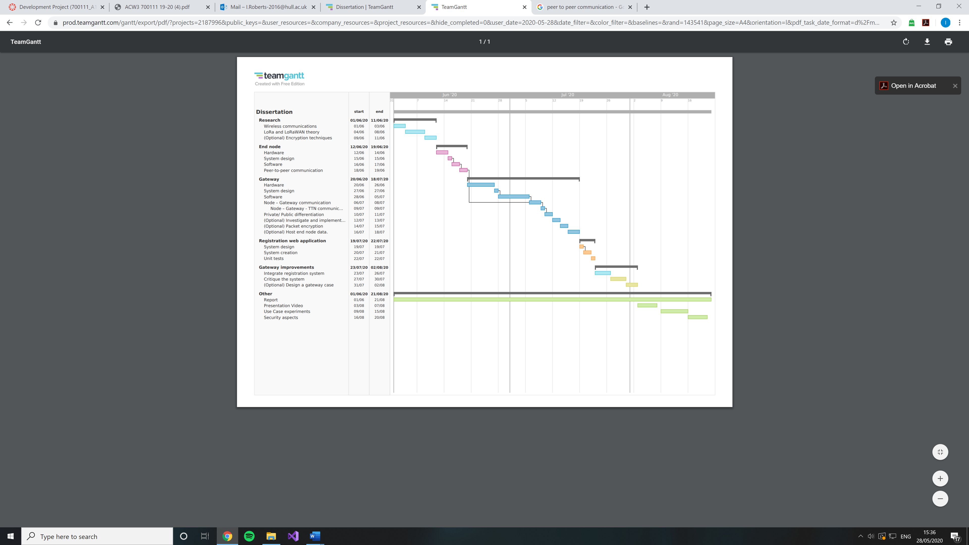

**Figure 31, Gantt chart for project made using TeamGannt**

# Conclusion, discussion and evaluation

# Appendix

## Appendix 1.1: Original topic description

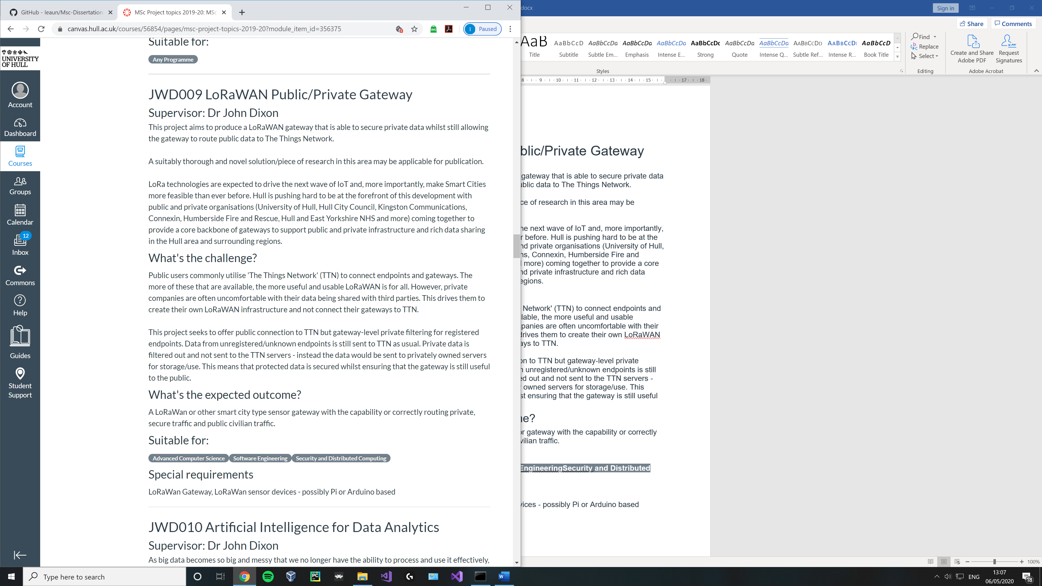

## Appendix 1.2: Ethics form

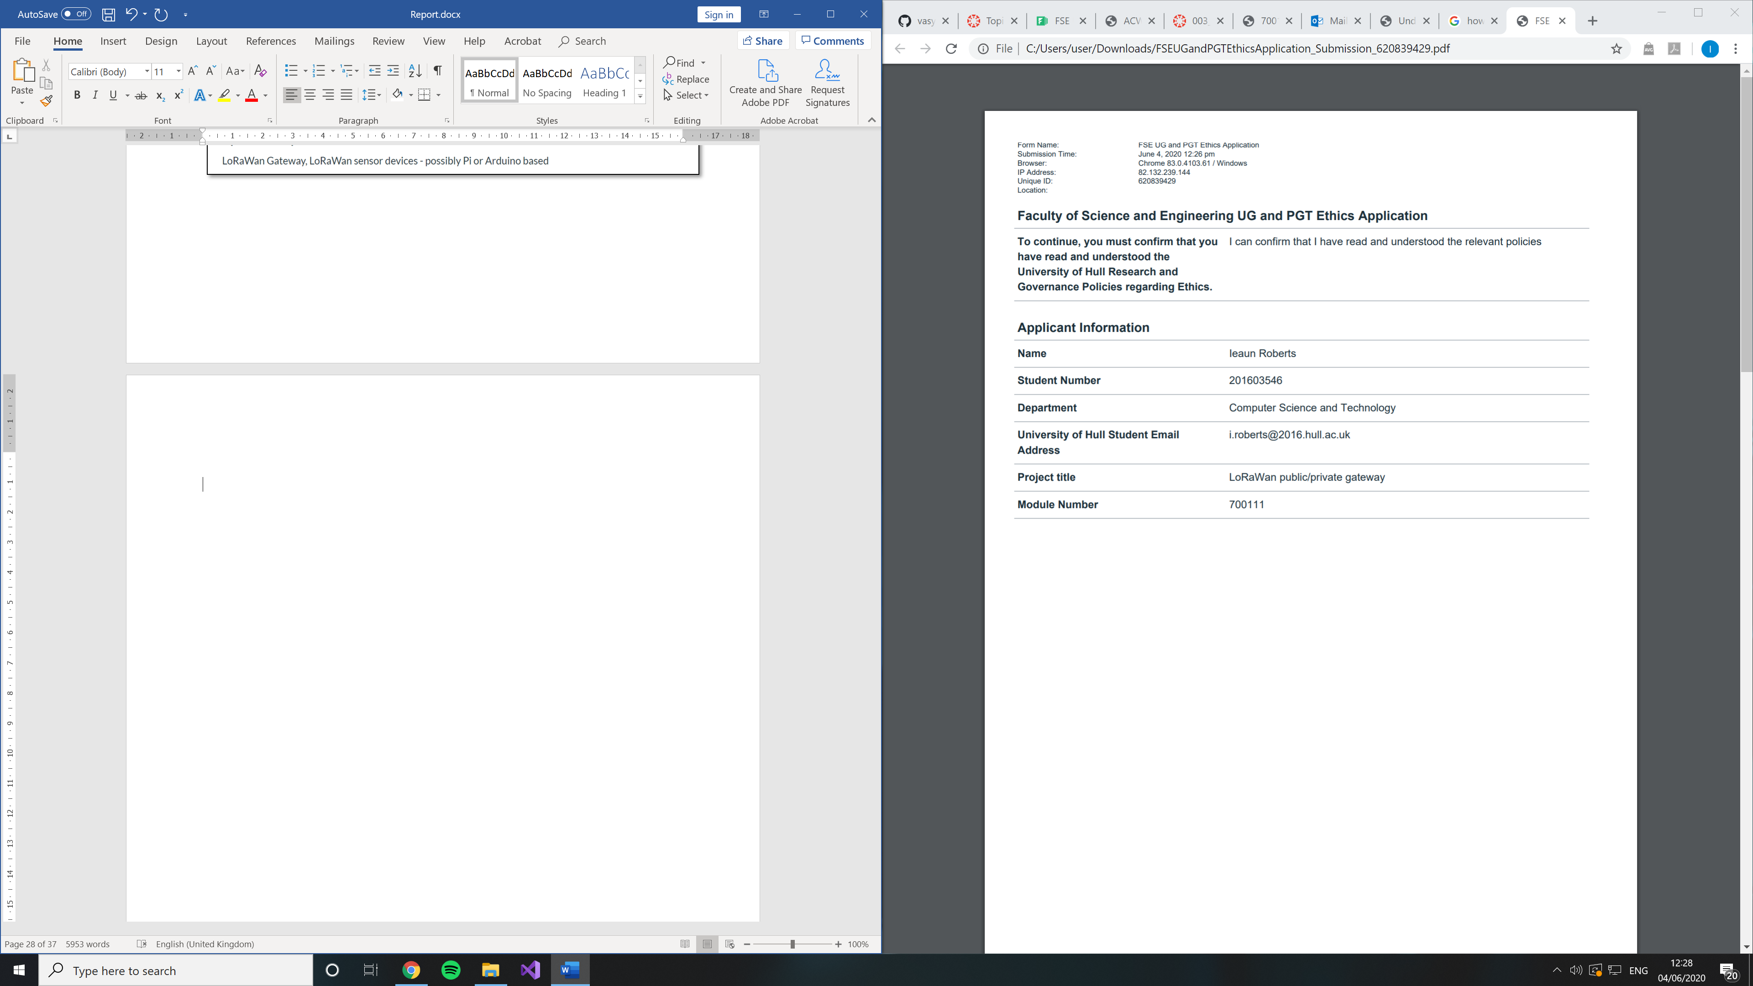

## Appendix 1.3:

##### Gateways in central London, UK

##### What gateways are they using ?

**Figure above left, LoRaWan at position 7 in adjacent table with altitude of 168** (thethingsnetwork, n.d.)

**Figure above , LoRaWan gateways in a subset of Central London, UK.** (thethingsnetwork, n.d.)

|  |  |  |
| --- | --- | --- |
| **No** | **Brand / Model** | **Altitude (m)** |
| 1 | Laird, Sentrius RG186 (x2) | 30 |
|  | Dragino, LG305 | 30 |
|  | Dragino, LPS8 | 30 |
| 2 | Kerlink, not specified | 26 |
|  | Multitech, not specified | 6 |
| Laird, Sentrius RG186 | 6 |
| 3 | MultiTech, not specified | 54 |
|  | Kerlink, not specified | 61 |
| 4 | Tektelic, KONA Micro | - |
|  | Kerlink, station | 68 |
| 5 | Raspberry Pi based, 831 | 3 |
|  | The Things Indoor Gateway | - |
| Kerlink, not specified | 76 |
| 6 | Kerlink, not specified | 54 |
|  | Kerlink, station | - |
| Kerlink, not specified | 62 |
| 7 | Raspberry Pi based, PiSupply | 15 |
|  | Raspberry Pi based | 168 |
| The Things Indoor Gateway | 35 |
| 8 | Kerlink, not specified | 69 |
|  | Raspberry Pi based, 7243 | 60 |
| 9 | Laird, Sentrius RG186 | 19 |
|  | The Things Indoor Gateway | 20 |
|  | The Things Gateway | 18 |
| 10 | Kerlink, not specified | 20 |
|  | | |
|  | Kerlink | 43 |

##### Gateways in Manchester, UK

##### What gateways are they using ?

|  |  |  |
| --- | --- | --- |
| **No** | **Brand / Model** | **Altitude (m)** |
| 1 | Kerlink, Station | 27 |
| 2 | - | 20 |
| 3 | TTN-001-868-1.0 | - |
|  | Kerlink, Station | - |
| 4 | The Things Gateway | 26 |
|  | Kerlink, Station | - |
|  | Kerlink, Station | - |
| 5 | Kerlink, Station | - |
|  | Laird, Sentrius RG186 | 48 |
|  | The Things Indoor Gateway | 74 |
| 6 | - | 80 |
| 7 | Laird, not specified | - |
|  | Laird, Sentrius RG186 | - |
|  | | |
|  | Kerlink, Station | 46 |

**Figure above , LoRaWan gateways in a subset of Manchester, UK.** (thethingsnetwork, n.d.)

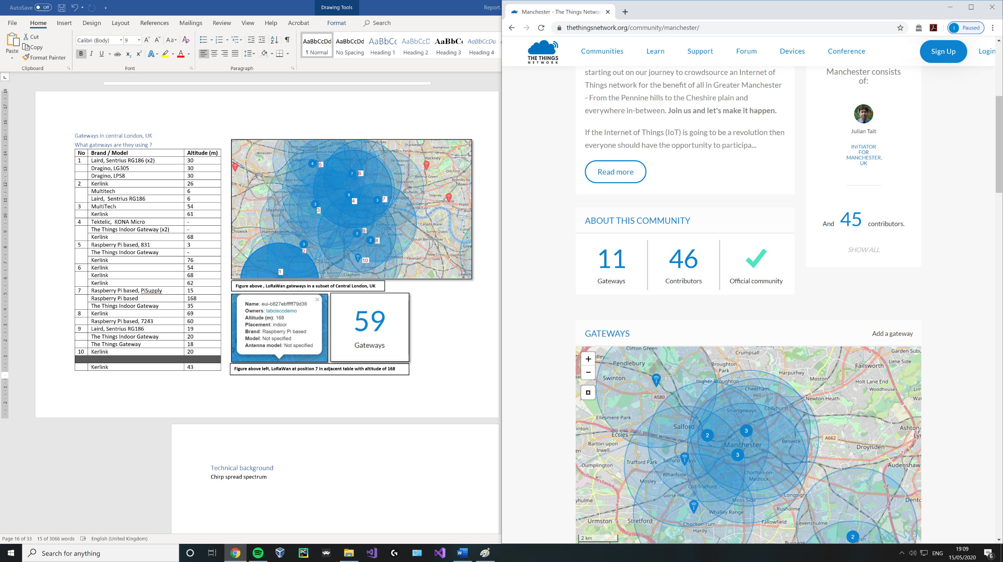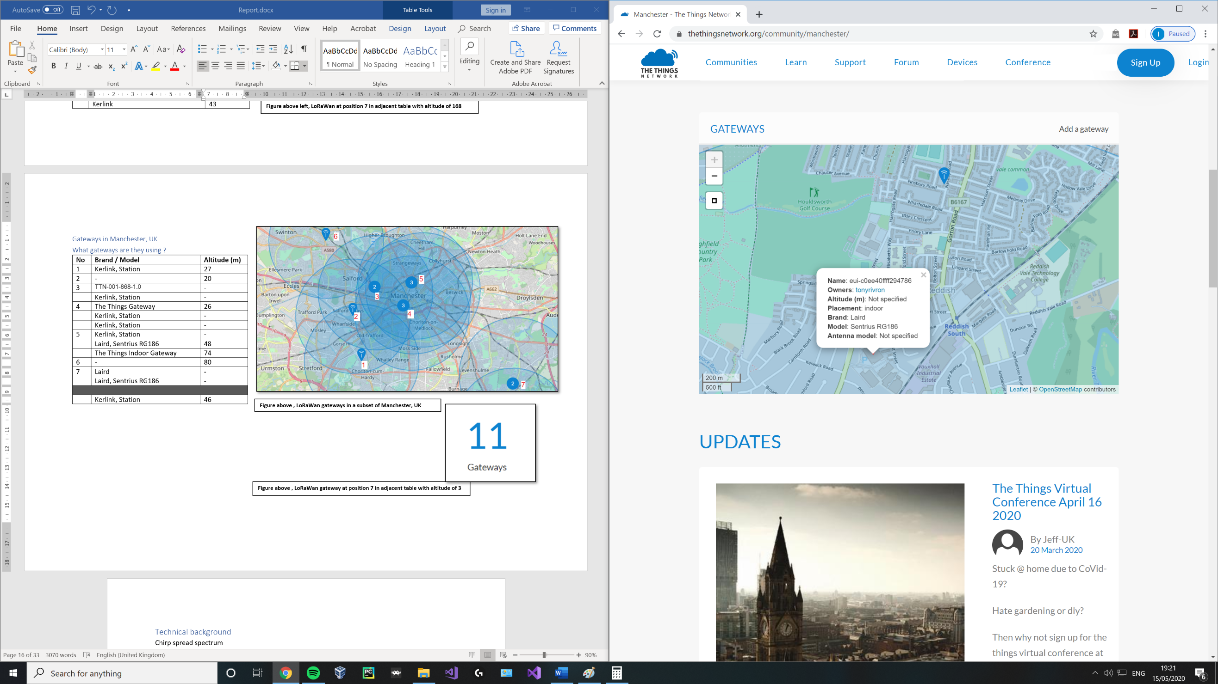

**Figure above , LoRaWan gateway at position 7 in adjacent table using a Laird Sentruis** (thethingsnetwork, n.d.)

##### Gateways in Liverpool, UK

##### What gateways are they using ?

**Figure above , LoRaWan gateways in a subset of Liverpool, UK.** (thethingsnetwork, n.d.)

|  |  |  |
| --- | --- | --- |
| **No** | **Brand / Model** | **Altitude (m)** |
| 1 | Raspberry Pi based | 22 |
|  | - | 107 |
|  | Raspberry Pi based | - |
|  | IOTLTD v. 10 | 42 |
|  | IOTLTD v. 10 | 93 |
|  | IOTLTD v. 10 | 87 |
|  | The Things Indoor Gateway | 20 |
| 2 | IOTLTD | - |
|  | Raspberry Pi based | - |
|  | Raspberry Pi with IMST iC880A | 3 |
|  | IOTLTD v. 10 | 28 |
|  | Gemtek, TTIOG | 30 |
|  | Laird Sentrius RG186 | 60 |
|  | The Things Indoor Gateway | - |
|  | The Things Gateway | 46 |
|  | IOTLTD v. 10 | 176 |
|  | - | 82 |
|  | Raspberry Pi based | 5 |
| 3 | Raspberry Pi based | 70 |
|  | Raspberry Pi based, IMST | - |
|  | Raspberry Pi based | - |
|  | Raspberry Pi based | - |
|  | | |
|  | IOTLTD v. 10 | 58 |

**Figure above , LoRaWan gateway at position 2 in adjacent table using a Laird Sentruis.** (thethingsnetwork, n.d.)

##### Gateways in Birmingham, UK

##### What gateways are they using ?

|  |  |  |
| --- | --- | --- |
| **No** | **Brand / Model** | **Altitude (m)** |
| 1 | MultiTech, Conduit | 20 |
| 2 | The Things Indoor Gateway | - |
| 3 | The Things Indoor Gateway | - |
|  | The Things Indoor Gateway | - |
|  | | |
|  | The Things Indoor Gateway | 20 |

**Figure above , LoRaWan gateways in a subset of Birmingham, UK.** (thethingsnetwork, n.d.)

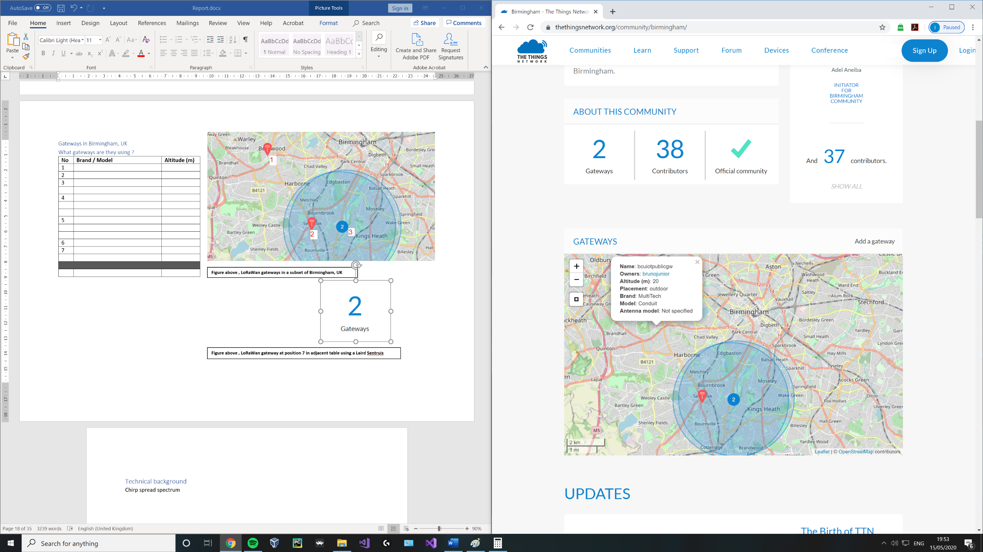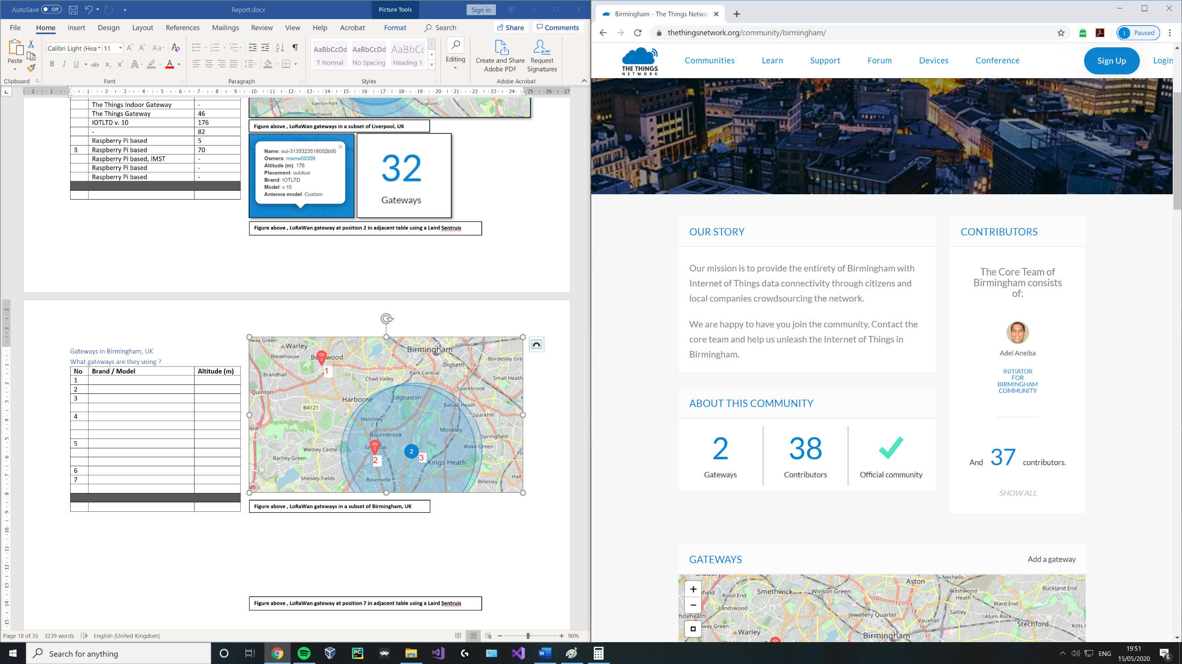

**Figure above , LoRaWan gateway at position 1 in adjacent table using a MultiTech, Conduit** (thethingsnetwork, n.d.)

##### Gateways in Leeds and Bradford, UK

##### What gateways are they using ?

|  |  |  |
| --- | --- | --- |
| **No** | **Brand / Model** | **Altitude (m)** |
| 1 | Raspberry Pi based, RAK831 | - |
| 2 | Kerlink, Station | 173 |
| 3 | Kerlink, Station | 154 |
| 4 | Kerlink, Femtocell | 4 |
|  | MultiTech, Conduit | 50 |
|  | The Things Indoor Gateway | - |
| 5 | Beagle Bone Black with RAK831 | 120 |
|  | Cisco, IXM | - |
|  | MultiTech, Conduit | 50 |
|  | | |
|  | Kerlink, Station /  MultiTech, Conduit | 92 |

**Figure above , LoRaWan gateways in Leeds and Bradford, UK** (thethingsnetwork, n.d.)

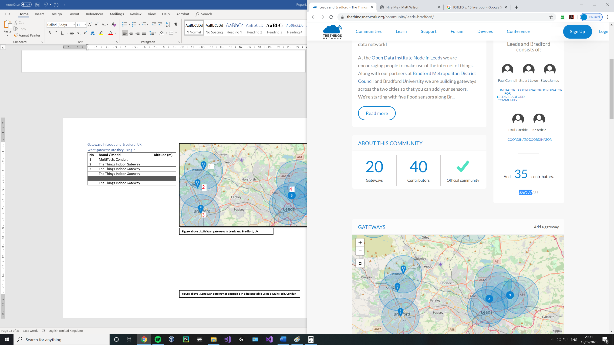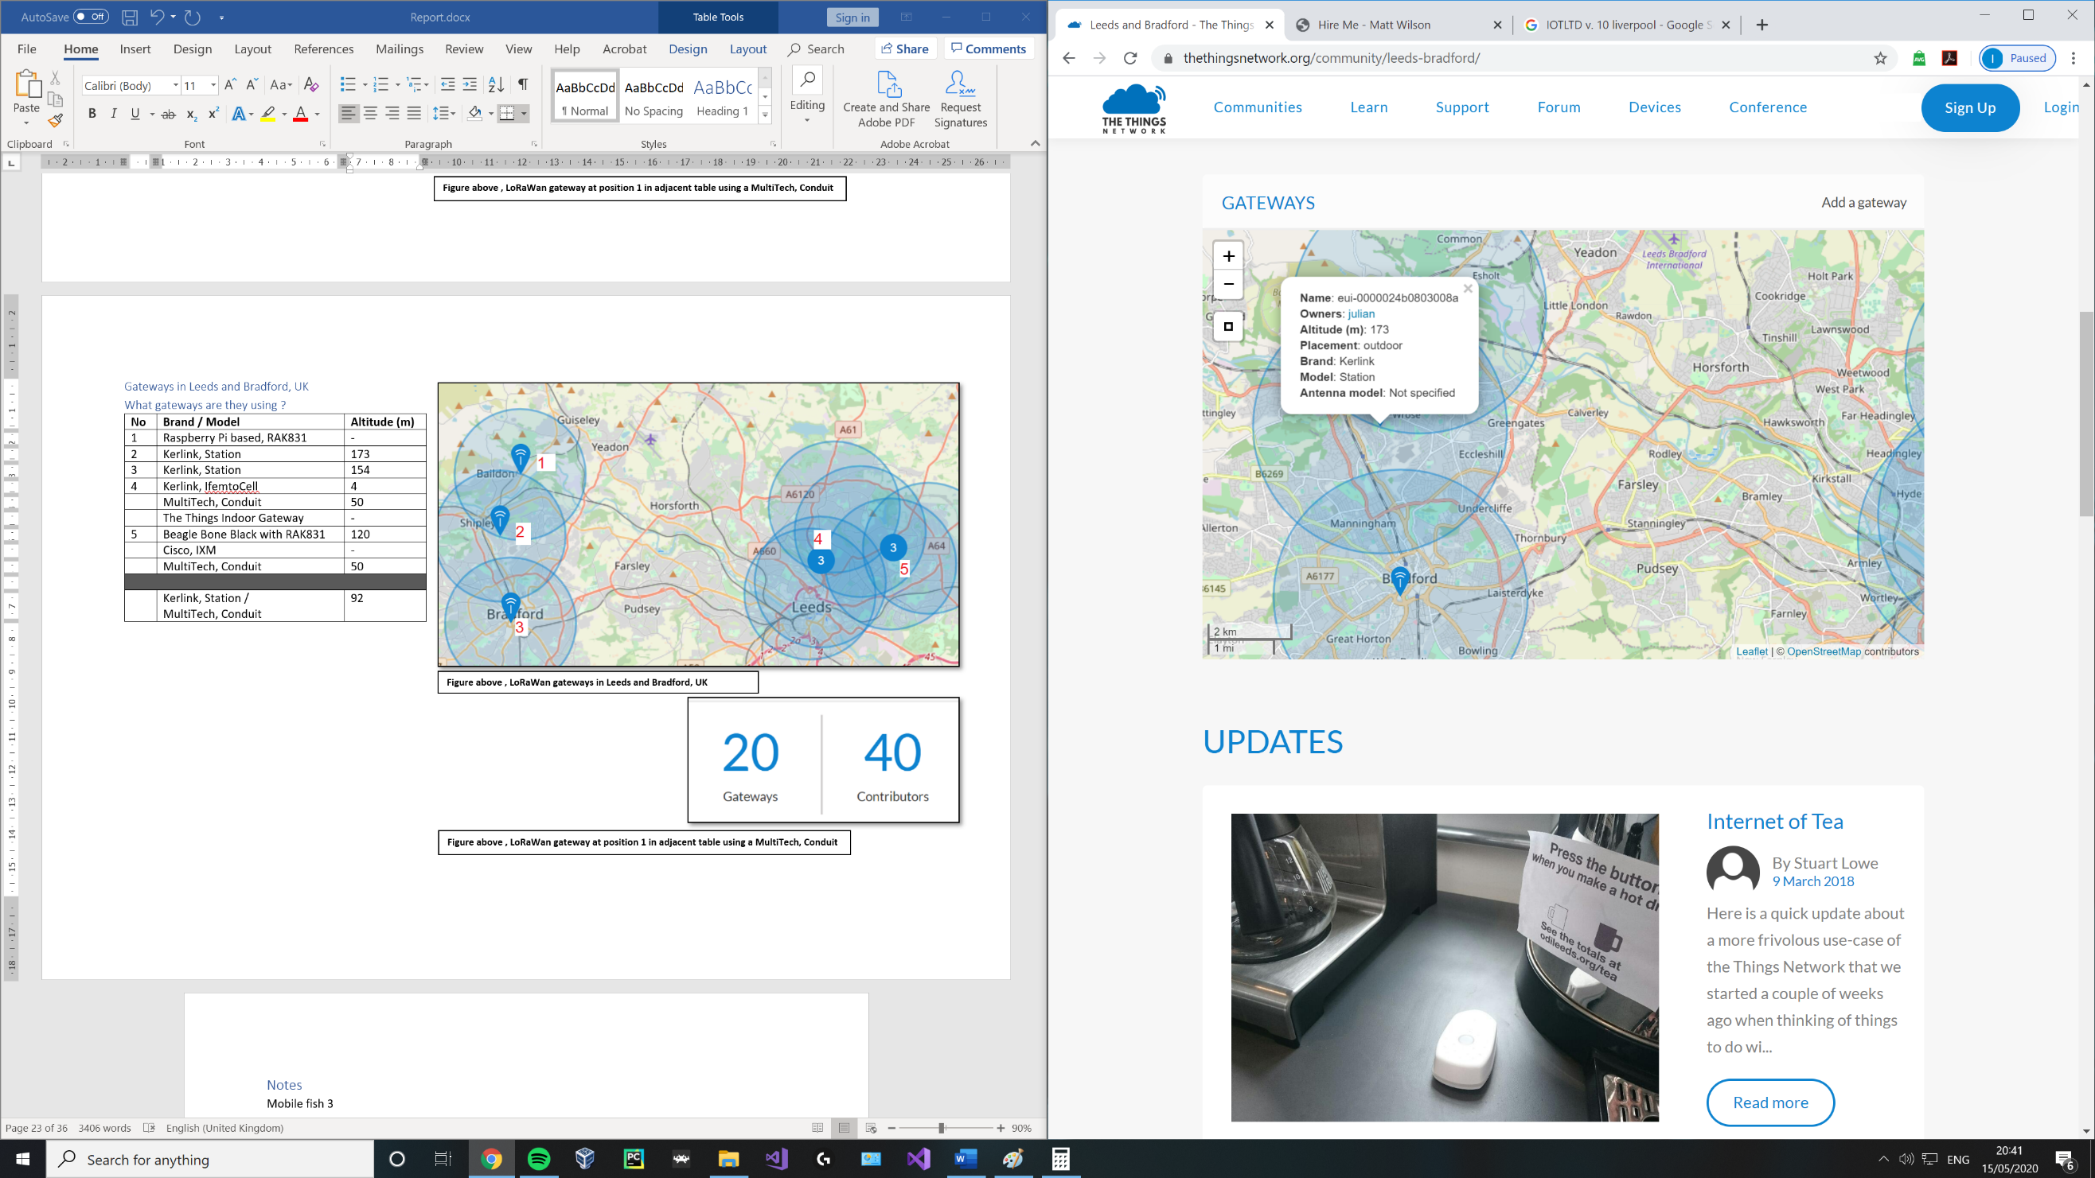

**Figure above , LoRaWan gateway at position 1 in adjacent table using a MultiTech, Conduit** (thethingsnetwork, n.d.)

# References

Akira, I., 24 March 2010. *Illustration of Frequency Modulation,* s.l.: WikiMedia Commons.

Angular.io, 2020. *https://angular.io/.* [Online]   
Available at: https://angular.io/  
[Accessed 30 December 2020].

Anon., n.d. [Online].

Antratek, 2020. *www.antratek.com.* [Online]   
Available at: https://www.antratek.com/10-channel-lorawan-gateway-4g  
[Accessed 2020].

britannica, n.d. *britannica.com.* [Online]   
Available at: https://www.britannica.com/technology/modulation-communications  
[Accessed 27 05 2020].

Britannica, T. E. o. E., December 23, 2014. *www.britannica.com.* [Online]   
Available at: https://www.britannica.com/technology/modulation-communications  
[Accessed 30 December 2020].

chirpstack, n.d. *https://www.chirpstack.io/.* [Online]   
Available at: https://www.chirpstack.io/  
[Accessed 2 January 2021].

Cola, P., 2018. *linkedin.com.* [Online]   
Available at: https://www.linkedin.com/pulse/ip-over-lorawan-philippe-cola  
[Accessed 05 2020].

D-Link, n.d. *https://eu.dlink.com.* [Online]   
Available at: https://eu.dlink.com/uk/en/support/faq/access-points-and-range-extenders/what-is-spread-spectrum  
[Accessed 31 December 2020].

dragino, 2019. *dragino.com.* [Online]   
Available at: https://www.dragino.com/products/module/item/102-lora-shield.html  
[Accessed May 2020].

Dragino, 2020. *https://wiki.dragino.com/index.php?title=Lora_Shield.* [Online]   
Available at: https://wiki.dragino.com/index.php?title=Lora_Shield  
[Accessed 23 July 2020].

ElectronicsNotes, n.d. *https://www.electronics-notes.com/articles/radio/dsss/what-is-direct-sequence-spread-spectrum.php.* [Online]   
Available at: https://www.electronics-notes.com/articles/radio/dsss/what-is-direct-sequence-spread-spectrum.php  
[Accessed 31 December 2020].

electronicspecifier, 2020. *electronicspecifier.com.* [Online]   
Available at: https://www.electronicspecifier.com/news/analysis/managing-power-in-the-iot-with-cellular-lpwan-technology  
[Accessed 05 2020].

EMMA GOOD, F. J., 2018. *Evaluating LoRaWAN for IoT applications by developing a wireless parking space monitoring sensor,* STOCKHOLM, SWEDEN: KTH ROYAL INSTITUTE OF TECHNOLOGY.

GEMALTO, ACTILITY AND SEMTECH, 2017. *LoraWAN security, Full end-to-end encryption for IOT application providers,* s.l.: Lora Alliance.

kerlink, n.d. *kerlink.com.* [Online]   
Available at: https://www.kerlink.com/product/wirnet-station/  
[Accessed 14 05 2020].

lora-alliance, 2015. *lora-alliance.org.* [Online]   
Available at: https://lora-alliance.org/sites/default/files/2018-05/2015_-_lorawan_specification_1r0_611_1.pdf#page=34  
[Accessed 26 05 2020].

lora-alliance, n.d. *lora-alliance.org.* [Online]   
Available at: https://lora-alliance.org/about-lorawan  
[Accessed 27 05 2020].

lora-alliance, n.d. *lora-alliance.org/sites/default/files/2019-05/lorawan_security_whitepaper.* [Online]   
Available at: https://lora-alliance.org/sites/default/files/2019-05/lorawan_security_whitepaper.pdf  
[Accessed 16 May 2020].

lora-developers, n.d. *https://lora-developers.semtech.com.* [Online]   
Available at: https://lora-developers.semtech.com/library/tech-papers-and-guides/lora-and-lorawan/  
[Accessed 31 December 2020].

lora-developers, n.d. *lora-developers.semtech.com/library/tech-papers-and-guides/lorawan-class-a-devices/.* [Online]   
Available at: https://lora-developers.semtech.com/library/tech-papers-and-guides/lorawan-class-a-devices/  
[Accessed 25 05 2020].

Matthijskooijman, 2020. *GitHub.* [Online]   
Available at: https://github.com/matthijskooijman/arduino-lmic  
[Accessed 3 January 2021].

McCauley, M., 2020. *http://www.airspayce.com/mikem/arduino/RadioHead/.* [Online]   
Available at: http://www.airspayce.com/mikem/arduino/RadioHead/  
[Accessed 25 June 2020].

Microsoft, 2020. *https://www.typescriptlang.org.* [Online]   
Available at: https://www.typescriptlang.org/  
[Accessed 30 December 2020].

mobilefish, 2018. *www.mobilefish.com.* [Online]   
Available at: https://www.mobilefish.com/download/lora/lora_part7.pdf  
[Accessed 14 05 2020].

Mobilefish, 2018. *www.mobilefish.com.* [Online]   
Available at: https://www.mobilefish.com/download/lora/lora_part6.pdf  
[Accessed 13 05 2020].

MobileFish, 2018. *www.mobilefish.com.* [Online]   
Available at: https://www.mobilefish.com/download/lora/lora_part4.pdf  
[Accessed 14 05 2020].

Mobilefish, 2018. *www.mobilefish.com/download/lora/lora_part3.pdf.* [Online]   
Available at: https://www.mobilefish.com/download/lora/lora_part3.pdf  
[Accessed May 2020].

Mobilefish, 2018. *www.mobilefish.com/download/lora/lora_part7.pdf.* [Online]   
Available at: https://www.mobilefish.com/download/lora/lora_part7.pdf  
[Accessed 15 05 2020].

mobilefish, 2018. *www.mobilefish.com/download/lora/lora_part8.pdf.* [Online]   
Available at: https://www.mobilefish.com/download/lora/lora_part8.pdf  
[Accessed 28 May 2020].

N. Sornin (Semtech), M. L. (. T. E. (. T. K. (., 2015. *LoRaWAN Specification.* 1.0 ed. CA: LoRa Alliance .

ni, 2020. *https://www.ni.com.* [Online]   
Available at: https://www.ni.com/en-gb/innovations/white-papers/06/understanding-spread-spectrum-for-communications.html  
[Accessed 31 December 2020].

RAK, n.d. *doc.rakwireless.com.* [Online]   
Available at: https://doc.rakwireless.com/datasheet/rakproducts/rak811-lora-module-datasheet  
[Accessed 15 05 2020].

semtech, n.d. *semtech.com.* [Online]   
Available at: https://www.semtech.com/products/wireless-rf/lora-transceivers/sx1272  
[Accessed 05 2020].

semtech, n.d. *semtech.com.* [Online]   
Available at: https://www.semtech.com/lora/what-is-lora  
[Accessed 05 26 2020].

semtech, n.d. *semtech.com.* [Online]   
Available at: https://www.semtech.com/lora/lora-applications/smart-healthcare  
[Accessed 26 05 2020].

semtech, n.d. *www.semtech.com/products/wireless-rf/lora-gateways/sx1301.* [Online]   
Available at: https://www.semtech.com/products/wireless-rf/lora-gateways/sx1301  
[Accessed 10 May 2020].

Seneviratne, P., 2019. *Beginning Lora Radio networks with arduino.* 1st ed. s.l.:Apress.

Skrypt, 2019. *hackaday.io.* [Online]   
Available at: https://hackaday.io/project/164242-skrypt  
[Accessed May 2020].

Supply, P., n.d. *uk.pi-supply.com.* [Online]   
Available at: https://uk.pi-supply.com/products/rak811-lora-lorawan-tracker-board-wireless-remote-positioning-solution-max-7q-gps-module-mems-sensor  
[Accessed 13 05 2020].

Telkamp, T., 2016. *LoRa crash course,* s.l.: s.n.

The Things network, n.d. *https://www.thethingsnetwork.org/docs/lorawan/security.* [Online]   
Available at: https://www.thethingsnetwork.org/docs/lorawan/security.html  
[Accessed 2 January 2021].

thethingsnetwork, n.d. *https://www.thethingsnetwork.org/community/birmingham/.* [Online]   
Available at: https://www.thethingsnetwork.org/community/birmingham/  
[Accessed 16 May 2020].

thethingsnetwork, n.d. *https://www.thethingsnetwork.org/community/leeds-bradford/.* [Online]   
Available at: https://www.thethingsnetwork.org/community/leeds-bradford/  
[Accessed 16 May 2020].

thethingsnetwork, n.d. *thethingsnetwork.org.* [Online]   
Available at: https://www.thethingsnetwork.org/docs/lorawan/duty-cycle.html#maximum-duty-cycle  
[Accessed 26 05 2020].

thethingsnetwork, n.d. *thethingsnetwork.org maximum-duty-cycle.* [Online]   
Available at: https://www.thethingsnetwork.org/docs/lorawan/duty-cycle.html#maximum-duty-cycle  
[Accessed 26 05 2020].

thethingsnetwork, n.d. *thethingsnetwork.org/community/hull.* [Online]   
Available at: https://www.thethingsnetwork.org/community/hull/  
[Accessed 16 May 2020].

thethingsnetwork, n.d. *thethingsnetwork.org/docs/gateways/.* [Online]   
Available at: https://www.thethingsnetwork.org/docs/gateways/  
[Accessed 28 June 2020].

thethingsnetwork, n.d. *www.thethingsnetwork.org.* [Online]   
Available at: https://www.thethingsnetwork.org/docs/lorawan/classes.html  
[Accessed 27 05 2020].

thethingsnetwork, n.d. *www.thethingsnetwork.org/#metrics.* [Online]   
Available at: https://www.thethingsnetwork.org/#metrics  
[Accessed 26 May 2020].

thethingsnetwork, n.d. *www.thethingsnetwork.org/community/liverpool/.* [Online]   
Available at: https://www.thethingsnetwork.org/community/liverpool/  
[Accessed 16 May 2020].

thethingsnetwork, n.d. *www.thethingsnetwork.org/community/london/.* [Online]   
Available at: https://www.thethingsnetwork.org/community/london/  
[Accessed 16 May 2020].

thethingsnetwork, n.d. *www.thethingsnetwork.org/community/manchester/.* [Online]   
Available at: https://www.thethingsnetwork.org/community/manchester/  
[Accessed 16 May 2020].

Torrieri, D., 2015. *Principles of Spread-Spectrum.* 3rd ed. Maryland: Springer.

TTN, 2017. *thethingsnetwork.org.* [Online]   
Available at: https://www.thethingsnetwork.org/article/ground-breaking-world-record-lorawan-packet-received-at-702-km-436-miles-distance  
[Accessed 05 2020].

TutorialsPoint, 2016. *Digital communication.* s.l.:TutorialsPoint.

tutorialspoint, n.d. *https://www.tutorialspoint.com.* [Online]   
Available at: https://www.tutorialspoint.com/digital_communication/digital_communication_spread_spectrum_modulation.htm  
[Accessed 31 December 2020].

wienkegiezeman, 2015. *thethingsnetwork.org.* [Online]   
Available at: https://www.thethingsnetwork.org/forum/t/the-things-network-launches/33  
[Accessed 13 05 2020].

Worthman, E., 2015. *https://semiengineering.com/a-new-infrastructure-for-the-ioe/.* [Online]   
Available at: https://semiengineering.com/a-new-infrastructure-for-the-ioe/  
[Accessed 2 January 2021].